**XPS Examination of the Oxide-Metal Interface of an Aluminum-Magnesium Alloy Containing Beryllium**

Nicholas Smith1, Anne Kvithyld2, Gabriella Tranell1

1NTNU Alfred Getz Vei 2, 7034 Trondheim, Norway

2SINTEF P.O. Box 4760 Sluppen, 7465 Trondheim, Norway

Keywords: Aluminum, Beryllium, Oxidation

**Abstract**

The addition of beryllium to high magnesium aluminum alloys has long been known to cause a significant decrease in the rate of alloy oxidation. A clear understanding of the fundamental mechanism behind this effect is still lacking. Previous work by the authors has shown that the first formed oxide layer and the oxide metal interface is of key importance. To understand the behavior of beryllium during oxidation, a detailed characterization of the metal/oxide interface was therefore carried out. XPS (X-Ray Photoelectron Spectroscopy) was used to study the oxide layer of an Al-5%Mg alloy containing an elevated beryllium content of 100 ppm, which had been oxidized in air at 550 and 700 °C. The higher concentration of beryllium than is used by industry was done to enhance its effects for easier characterization. For samples below the alloy melting point BeO-Al2O3 growths were found on the surface underneath an MgO layer. For liquid metal samples, the BeO-Al2O3 formed as a layer underneath an MgO layer.

**Introduction**

Additions of ppm levels of beryllium to aluminum magnesium alloys has a well-established impact on the oxidation characteristics of the alloy. Previous work has shown that up to a tenfold decrease in the amount of oxidation can be seen with the addition of 2 ppm of beryllium to an industrial 5000 series alloy and is able to delay breakaway oxidation by several hours [1] [2] [3]. Given the small amounts used and the inability of many analysis methods to accurately detect beryllium, a detailed understanding of the mechanism behind beryllium’s large impact on oxidation remains unknown. A better understanding of the mechanism is desirable to help facilitate a move to an alternative method of oxidation protection that does not have the negative health impacts that are associated with beryllium and beryllium oxide, but offers a similar protective effect.

To shed light on the protective mechanism, the oxide layer and oxide/metal interface have been examined using X-Ray Photoelectron Spectroscopy (XPS) combined with argon sputtering to develop a clear depth profile from the top surface of the oxide layer to the base metal after an oxidation cycle at 550 °C. An artificial alloy containing only aluminum, magnesium and beryllium was made to aid in the detection of the beryllium containing phase, however, the beryllium content was increased to 100 ppm. This amount is more than one order of magnitude higher than what is used for industrial alloys. It has been assumed that the reaction mechanism will not significantly change with the addition of 100 ppm instead of the 2 ppm that can be seen by industry. As a reference, a 5000 series industrial alloy with 2 ppm beryllium was examined in the XPS.

Degreve et. al. have previously published a depth profile of a 7075 series alloy that contained beryllium created by sputtering and analyzing with secondary-ion mass spectrometry [4]. It was shown that the beryllium is highly concentrated near the surface with the highest concentration of beryllium being just below the metal oxide interface as shown in Figure 1. Limited information about the alloy composition, oxidation parameters and no images before or after sputtering were given in the work so it will be difficult to make more than a general comparison to this work.

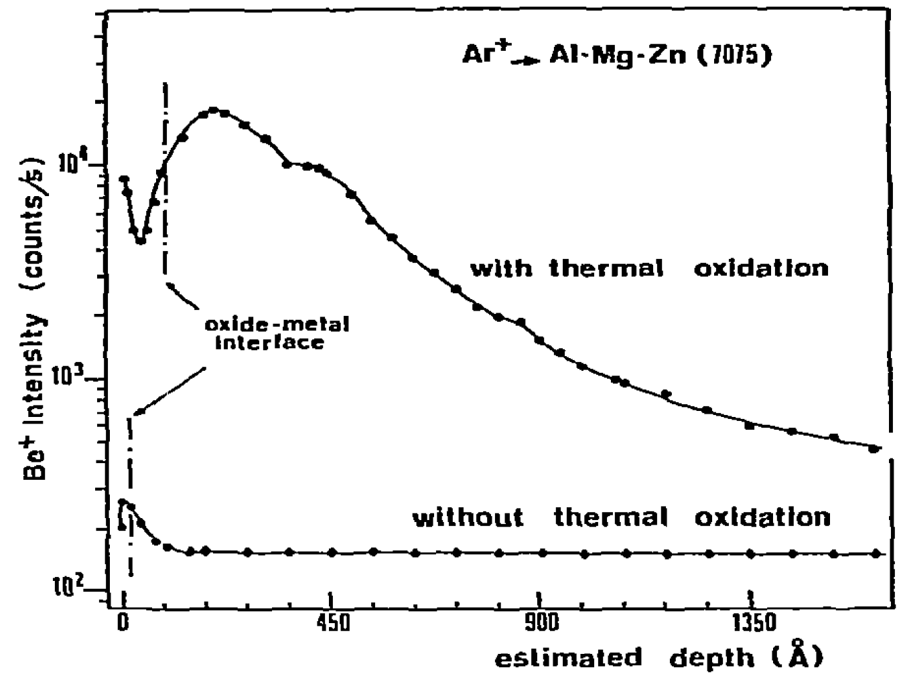

Figure 1 Results from Degreve et al showing beryllium depth profile [4].

**Experimental Procedure**

XPS coupled with argon sputtering was used to generate a depth profile through the oxide layer into the aluminum base metal. XPS depth profiles were generated on two different alloys:

1. A 5000-series industrial alloy containing 4.7 % magnesium with 2 ppm of beryllium
2. An artificial alloy containing 4.5 % magnesium with 100 ppm of beryllium.

The industrial sample was taken from the end cut of a DC cast ingot. The industrial sample was ground with 800 grit SiC paper before being oxidized at 700 °C for 2 hours in a synthetic air atmosphere. To generate a sample that would give clearer XPS results, an artificial alloy sample was made. To make the sample 99.999 % pure aluminum, 99.98 % pure magnesium and 99 % beryllium were charged into an alumina crucible. The crucible was placed inside a graphite crucible in an induction furnace and heated to 800 °C and held for 15 minutes. The sample was then cooled under an argon atmosphere, broken out of the alumina crucible and sectioned up into samples. ICP-MS showed the beryllium content to be 102 ppm and the magnesium content was between 4.5 and 5 %. The sample was polished to a 1 µm finish before being oxidized at 550 °C for times up to 6 hours in a horizontal tube furnace.

A temperature below the melting point was required to allow the sample to remain as flat as possible thus allowing the clearest depth profile possible to be generated. An additional sample of the same alloy was prepared with the same method, but oxidized at 700 °C for 6 hours to allow comparison between the morphology of the oxide layer of the samples from 550 °C and on a sample that was oxidized in the molten state. To compare the morphology between the samples a FEI Helios NanoLab DualBeam Focused Ion Beam Miller (FIB) was used to create a cross section though the oxide layer which was subsequently imaged with the SEM.

An AxisUltraDLD XPS from Kratos Analytical was used to generate the profile on the industrial sample, whereas, a Thetaprobe XP spectrometer from Thermo Scientific was used to generate the profile from the high beryllium sample. Sputtering was done with argon and an estimated sputter rate of:

1. 4 nm/30 seconds on the 2 ppm sample
2. 2 nm/30 seconds on the 100ppm samples

#### Results

## XPS results of 2 and 100 ppm samples

The XPS profile from the 2 ppm beryllium sample, is shown in Figure 2, did not reveal a curve for beryllium. The 100 ppm alloy samples showed a significant BeO curve as seen in Figure 3 for 60 minutes of oxidation time and Figure 4 for 360 minutes of oxidation time. The depth in the XPS profile is defined in sputtering time with longer times corresponding to a deeper depth measured from the surface of the oxide layer. XPS is able to differentiate between the different oxidation states of a specific element and, therefore, results are presented for both the metallic and oxide signals for select elements. The oxygen ion curves are not shown for clarity as the oxygen signals mirror their respective metal ion signal. Figures 3 and 4 show that initially the entire surface is MgO. The further inwards from the surface the amount of MgO decreases and the amount of Al2O3 and aluminum increases. Shortly following the increase in Al2O3 and aluminum, a BeO phase can be seen to develop as the Be 1s oxide signal does not increase from zero until several sputter cycles after the aluminum signal increases. This is similar to the beryllium curve published by Degreve et al. It cannot be determined by XPS if the initial Al 2s oxide signal is from Al2O3 or MgAl2O4.

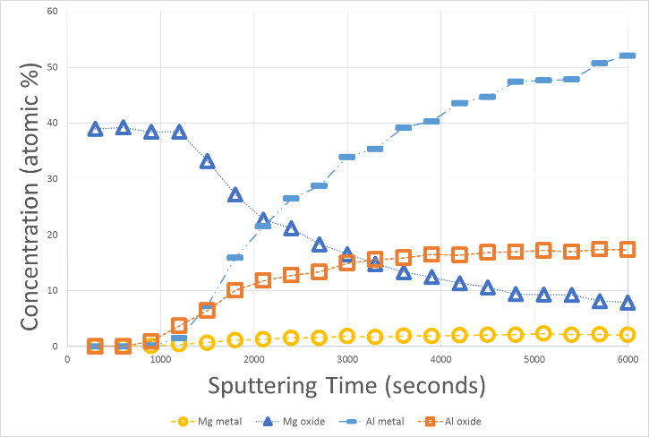

Figure 2 XPS profile from 5000 series 2 ppm industrial sample with no visible beryllium signal oxidized at 550 °C for 2 hours.

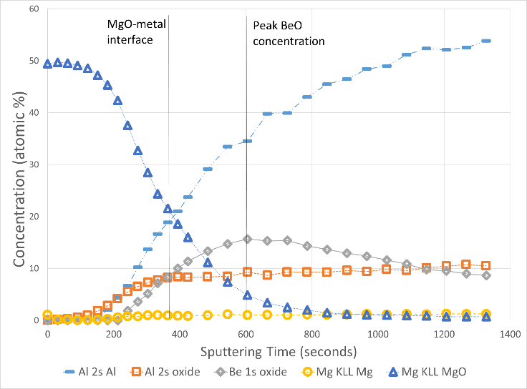

Figure 3 XPS profile for artificial alloy containing 100 ppm beryllium after oxidizing for 60 minutes at 550 °C showing a clear BeO signal underneath an MgO layer.

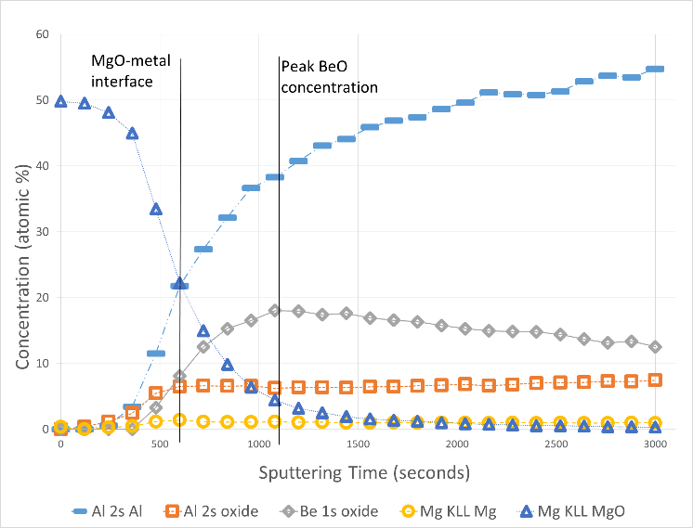

Figure 4 XPS profile for artificial alloy containing 100 ppm beryllium after oxidizing for 360 minutes at 550 °C showing a clear BeO signal underneath an MgO layer that is thicker than the layer on the 60 minute sample.

## SEM images of 360 minute sample with 100 ppm

Figures 5 and 6 show SEM images of the surface of the 100 ppm 360 minute sample before and after sputtering. Before sputtering the entire surface is covered with an MgO oxide layer that has a rough granular surface similar in appearance to what is typically seen on high magnesium alloys [5] [6] [7]. However, small growths out of the surface of the oxide are clearly visible. These small growths are not seen on a sample which was oxidized under the same conditions, but contained no beryllium. The distribution of the growths is not uniform across the sample surface with some areas containing large amounts and some areas containing few to none. It can be seen that after sputtering (the point corresponds to 3000 seconds on Figure 4), all MgO is gone and the sample surface is made up of 2 distinct phases - a bright phase on the surface and a dark background phase.

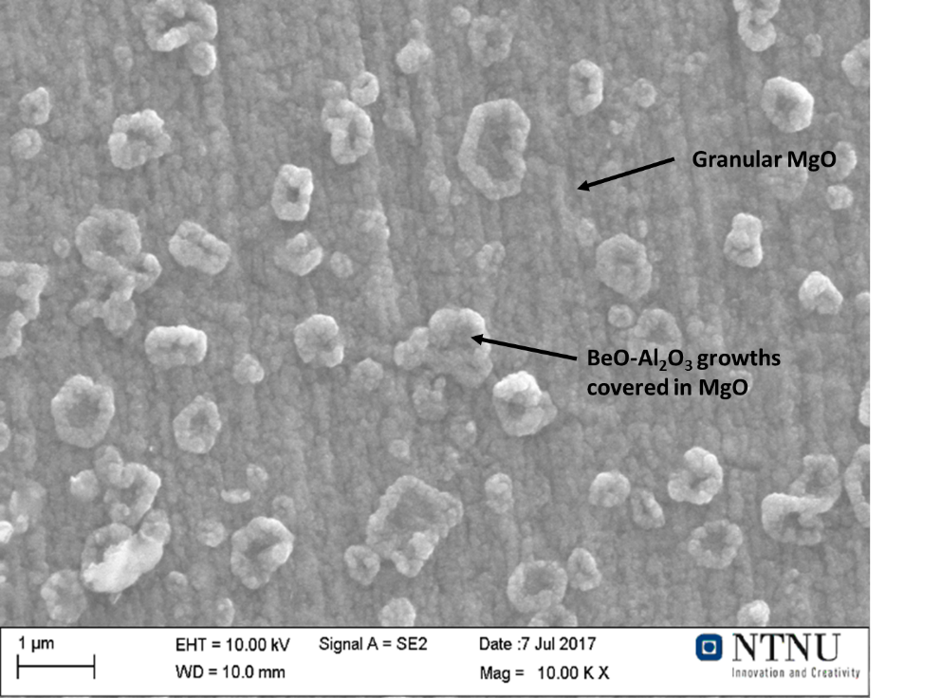

Figure 5 SEM image of the surface of 100 ppm beryllium sample from 360 minutes from outside the sputter crater showing the surface covered by a single phase that is MgO.

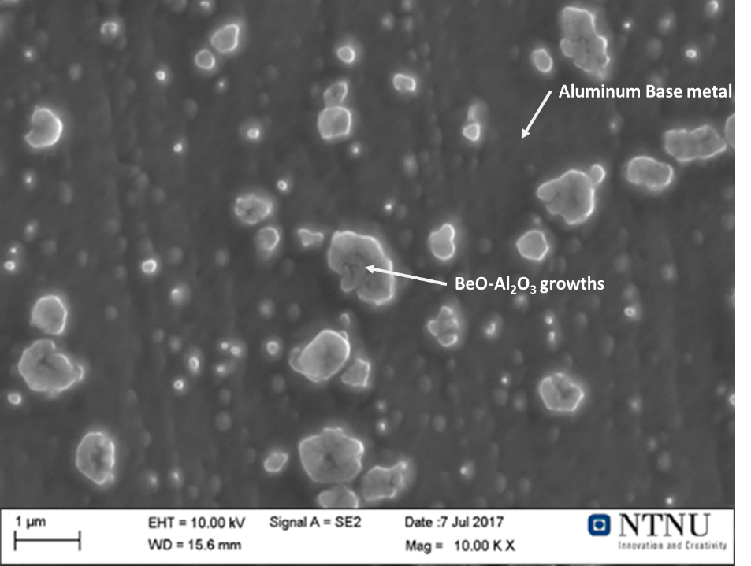

Figure 6 SEM image of the surface of 100 ppm beryllium sample from 360 minutes after 3000 seconds of sputtering showing a dark aluminum background with BeO-Al2O3 growths on the surface.

An Energy-dispersive X-ray spectroscopy (EDS) scan of the sputter crater shows that the dark background phase is made up of aluminum and magnesium with no significant oxygen peak. The bright phase shows aluminum and magnesium plus an additional oxygen peak as seen in Table 1. Note that Table 1 has been normalized to 100 %. The small size of the bright phase versus the large analysis volume of the EDS scan means that a significant amount of interference from the bulk metal occurs when analyzing the bright phase resulting in a higher Al and Mg and lower oxygen amounts. The 0.6 at% oxygen in the dark phase is within the background signal and can be neglected. As the XPS profile shows that BeO and Al2O3 are the only oxides present after sputtering the bright phase must be these oxides as it is the only phase with a measurable oxygen content. (Beryllium cannot be detected by an EDS scan and therefore for not included in Table 1)

Table 1 EDS scan of 100 ppm beryllium sample from the sputter crater (Figure 6) showing concentration in atomic percent.



## SEM and FIB examination of all samples

Examination of the samples in the SEM and FIB showed that the two types of growths were visible on the surface after oxidation:

1. Granular growth corresponding to MgO
2. Small growths that are identified as BeO-Al2O3.

A sample oxidized for only 30 minutes shows primarily MgO growth, but small regions of BeO-Al2O3 growth are visible. At times between 30 and 90 minutes the number of these growths increased. From 90 minutes the growths were nearly stable in size and shape as there is little change between the shape at 90 and 360 minutes. However, the MgO surrounding the growths continued to grow as seen in Figures 7 and 8 with Figure 7 showing a larger height difference between the tops of the growths and the MgO layer than in Figure 8. This is shown schematically in Figure 10. A cross section through the BeO-Al2O3 is shown in Figure 9 where it can be seen that both the oxide metal interface for the BeO-Al2O3 growth is slightly lower than for the MgO. No clear boundary between the MgO and BeO-Al2O3 could be seen.

Given that the BeO and Al2O3 signals quickly increase and reach a peak, then remain constant or decrease slowly after sputtering means that the surface area that is composed of these phases must remain nearly constant once the MgO layer has been completely removed. The constant signal indicates that the geometry of this phase is stable and does not change with additional sputtering. Therefore, the geometry of this phase must be similar at the peak BeO content and after the final sputtering cycle shown in Figure 5, meaning that the beryllium oxide does not exist as a single layer, but as clusters with Al2O3 for temperatures below the melting point.

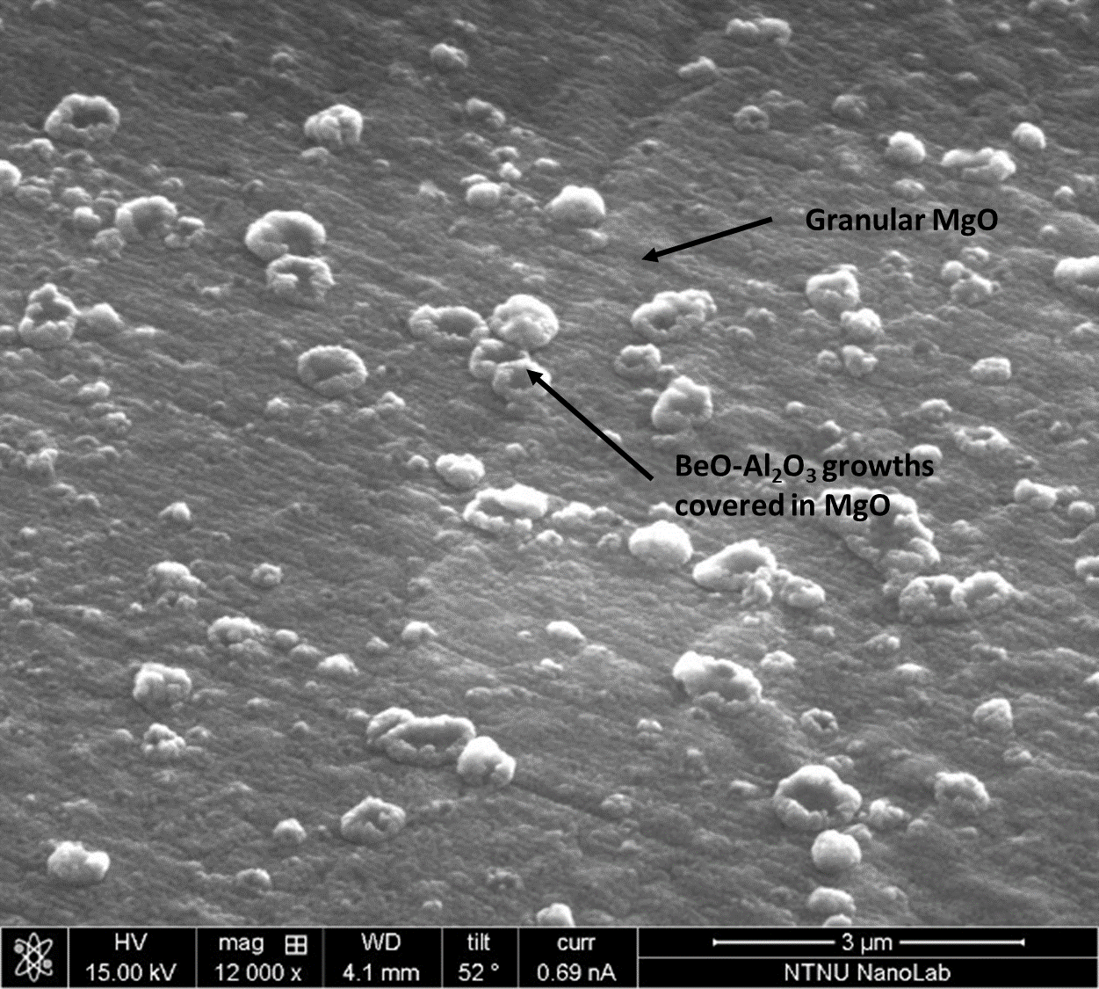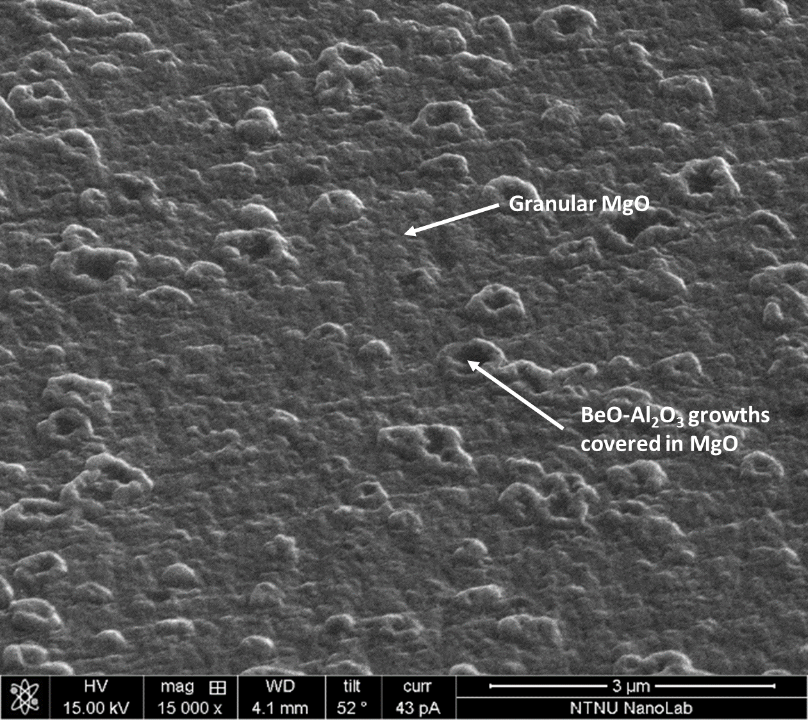

Figure 7 Sample from 90 minutes at 550 °C showing Figure 8 Sample from 360 minutes at 550 °C showing increased

minimal growth of MgO between BeO-Al2O3 growths MgO amounts between the BeO-Al2O3 growths

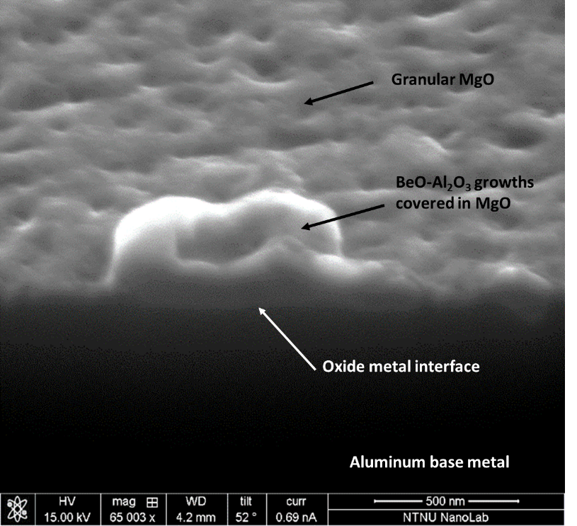

Figure 9 Cross section through growth on sample from 360 min at 550°C showing metal oxide interface of the BeO-Al2O3 growth is slightly lower than the MgO layer, but in general is a uniform interface.

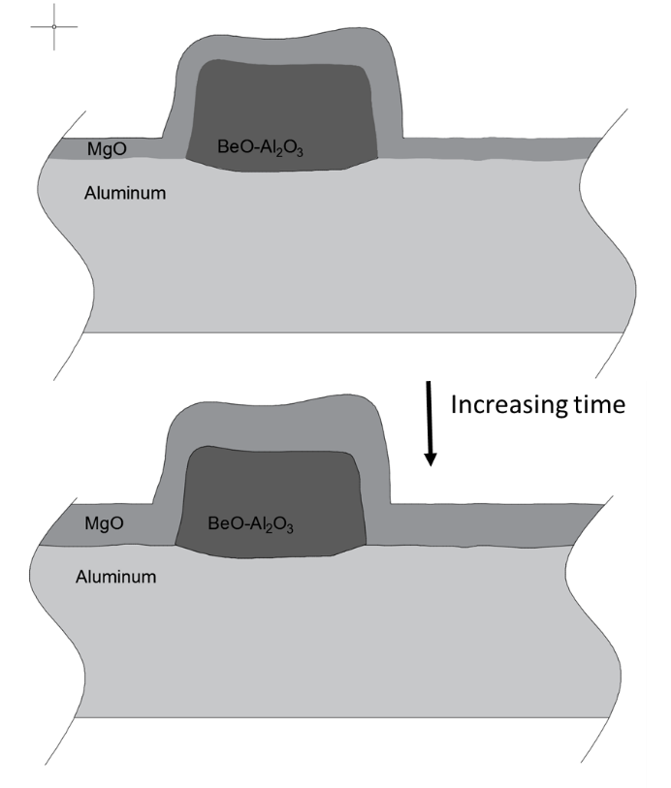

Figure 10 Schematic of oxide growth with time

On the 550 °C samples grain boundaries seemed to induce the formation of growths as a number of grain boundaries had significant growth along them as shown in Figure 11. The formation along grain boundaries was not consistent with some areas having it and others not. This increased formation is likely due to a higher diffusion rate of beryllium and magnesium along the grain boundaries.

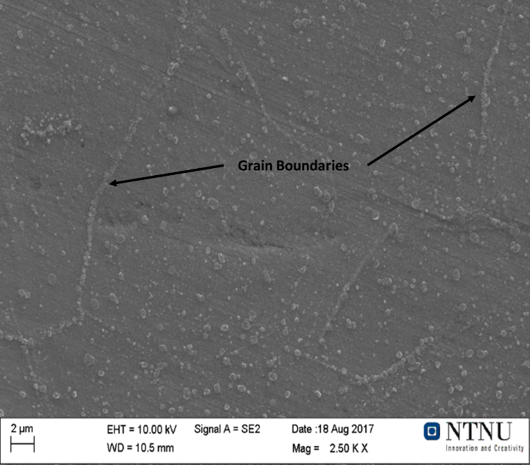

Figure 11 Growth of BeO-Al2O3 along grain boundaries of sample from 550 °C

The topography of the sample with 100 ppm beryllium from 700 ° C was too high to allow an XPS analysis to be carried out. The sample was characterized in the FIB for similarities to the solid samples. Between the MgO and aluminum base metal, a thin bright layer can be seen that is similar in location and contrast to the BeO-Al2O3 growths found in the sample from 550 °C. Figure 12 shows a FIB image of the layer after the MgO layer has been sputtered away and Figure 13 shows the layer schematically. The BeO-Al2O3 looks to be a nearly uniform layer with a thickness between 15 and 50 nm thick with an average of 30 nm as measured with the FIB. The exact composition of this layer has not been obtained.

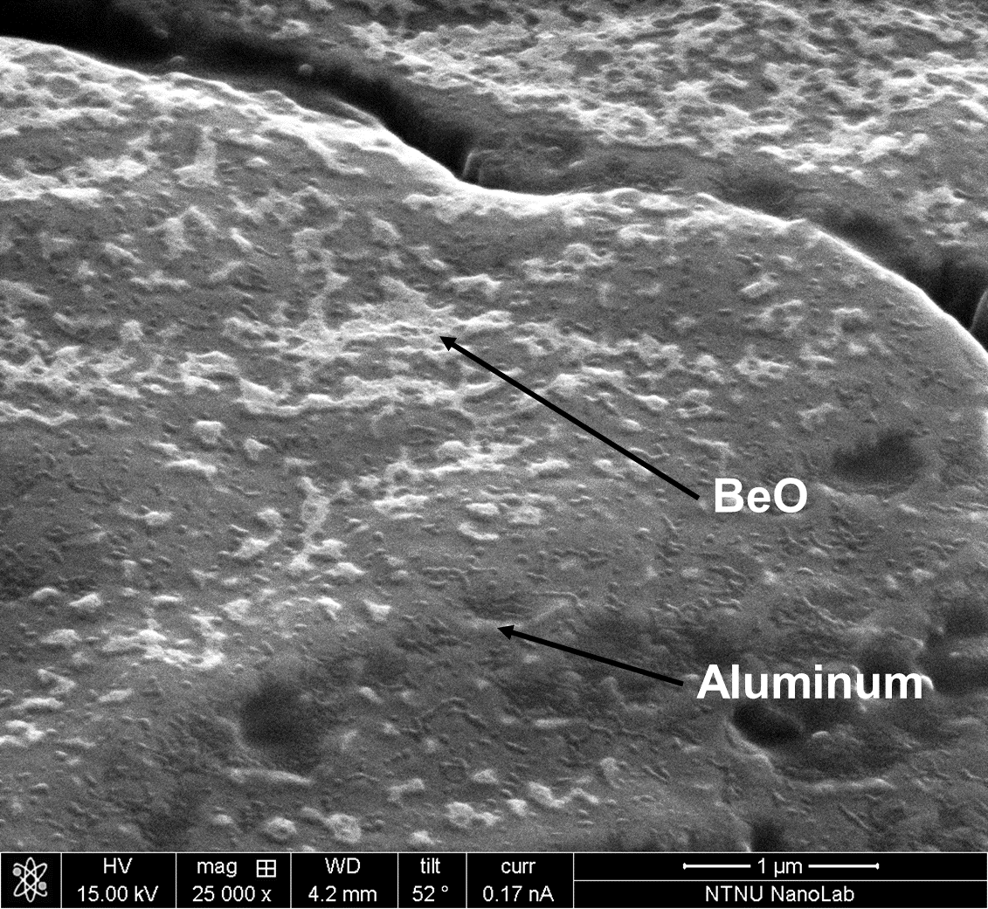

Figure 12 BeO-Al2O3 oxide layer on sample from 700 °C after MgO layer has been removed by sputtering

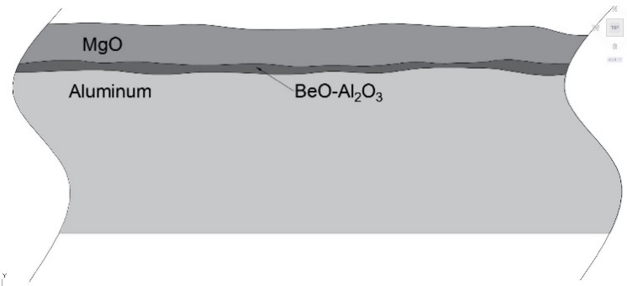

Figure 13 Schematic of the oxide layers on samples oxidized above the melting point of aluminum.

**Discussion**

The lack of a beryllium signal in the 2 ppm sample could be the result of two factors: the low level of beryllium and the uneven sample surface. The detection limit for the XPS is around 0.1 % meaning the beryllium may have been below the detection limit [8]. In addition, as the sample was only ground to 800 grit and heated to above the melting point resulting in a sample surface that had significant topography. This topography results in uneven sputtering and gives signal from both the metal and oxide simultaneously. The uneven sputtering likely resulted in the smaller beryllium signal being lost in the much higher MgO and metal signals.

The XPS curves from oxidation times of 60 and 360 minutes show a very similar profile, but with some important differences. All key transitions on the 60 minute sample occur at a shorter sputter time than the 360 minute sample. Meaning the primary difference between the samples is the thickness of the MgO layers. The oxide-metal on the 60 minute sample was reached after 375 seconds of sputtering whereas the 360 minute sample took 600 seconds to reach the interface. The peak BeO content was reached at 605 and 1080 seconds of sputtering for the 60 and 360 minute samples respectively. On both samples the BeO line trends down and the Al2O3 line trends upwards. On the 60 minute sample the concentration of Al2O3 exceeds the BeO concentration after 1145 seconds of sputtering this point is not reached on the 360 minute sample.

With respect to the BeO-Al2O3 phase found as clusters under/in the MgO phase, FactSage shows that the Al2O3 in this oxide layer should exist as BeAl2O4 sinceAl2O3 isnot a stable oxide phase in the presence of beryllium and magnesium. However, for BeAl2O4 to be present as a stoichiometric phase, the atomic concentration of the Al 2s oxide signal given by the XPS must be 2 times the Be 1s oxide concentration. This is not the case for either the 60 or 360 minute XPS curves meaning that BeO must exist along with BeAl2O4. As the Al 2s oxide signal increases over time it indicates that the BeO is transformed to BeAl2O4 as the amount of beryllium in the surface layer becomes depleted due to oxidation to BeO. This is a similar to the formation of the MgAl2O4 spinel phase which becomes stable when the magnesium activity drops below 0.025 [9]. The formation of a MgAl2O4 spinel phase is possible in the region before the BeO starts to form. After the BeO forms the Mg Kll oxide signal is no longer present so there cannot be a MgAl2O4 spinel phase. As the magnesium content becomes depleted near the interface, the magnesium activity will be sufficiently low to allow the spinel phase to form.

FIB images show that the oxide-metal interface is approximately at the same level for both the BeO-Al2O3 growths and MgO layer. The XPS results show that the aluminum signal increases before the BeO signal. This discrepancy means that the MgO layer away from the growths is thinner or sputters away at a faster rate than the MgO layer on top of the growths. This causes the BeO signal to appear later than the aluminum signal. Alternatively, if the spinel phase is present it could be responsible for the initial Al 2s oxide signal as the sputter rate is material dependent with denser materials being slower to sputter away. Therefore, once the aluminum matrix surrounding the BeO-Al2O3 growths is reached. It will sputter faster than the BeO-Al2O3 growths exaggerating the difference between the BeO-Al2O3 and matrix as seen in Figure 5.

If all the beryllium in the 100 ppm sample is oxidized to BeO the corresponding oxide layer would be approximately 300 nm thick. The oxide layer on the 700 °C sample is only 30 nm on average giving a beryllium “utilization” of 10 percent. Based on the sample size this would equate to a layer in the bulk aluminum that is depleted of beryllium of approximately 0.15 mm.

The XPS results show that at sputtering times over 1080 seconds, the magnesium content directly under the metal/oxide interface is significantly reduced to around 1 % from the bulk composition of 4.5 %. Therefore, it must be concluded that the transport of magnesium away from the oxide metal interface is faster than the diffusion of magnesium through the aluminum bulk. The presence of a magnesium depleted layer in the aluminum just beneath the oxide layer has been reported before by Lea and Molinari [10].

The XPS profiles for the 100 ppm samples show that the magnesium content in the layer just below the oxide layer is significantly lower than the bulk metal. Meaning the magnesium near the surface has been lost as MgO or magnesium vapor. The presence of magnesium in the EDS scans shown in Table 1 scans can be attributed to the bulk metal as the EDS scan gives information from the top µm of the surface, whereas the layer that is depleted of magnesium is significantly thinner than this.

**Conclusion**

**The surface features of a synthetic Al alloy containing 4.5% Mg and 100 ppm Be, oxidized at 550 and 700°C has been studied with XPS and FIB/SEM in order to better understand the protective mechanisms of Be on the oxidation of Mg-containing alloys. Based on the results of the study, the following conclusions can be drawn.**

* **The first formed oxide layer is MgO followed by Al2O3 and BeO**
* **Beryllium and magnesium are both oxidized and depleted from the surface layer of the metal and the reaction is further controlled by transport through the oxide layer.**
* **Beryllium is initially oxidized to BeO, but reacts to BeAl2O4 as the beryllium is depleted in the surface layer of the metal.**
* **BeO forms as growths with Al2O3 at the surface on samples oxidized below the melting point with preferential growth along grain boundaries.**
* **Above the alloy melting point, the BeO forms as a uniform thin layer at the metal/oxide interface. This uniform BeO containing layer on the metal/oxide interface helps to slow the transport of magnesium through the oxide layer where it is oxidized.**

**Acknowledgements**

This presentation has been funded by the SFI Metal Production, (Centre for Research-based Innovation, 237738). The authors gratefully acknowledge the financial support from the Research Council of Norway and the partners of the SFI Metal Production. Additionally, would like to thank Martin Sunding and Ingeborg-Helene Svenum from SINTEF for their help with the XPS analysis and Christian Simensen from SINTEF for his input in this work.

**References**

1. Thiele W (1962) Die Oxydation von Aluminium-und Aluminiumlegierungs-schmelzen. Aluminium 38:780-786
2. Cochran C, Belitskus D, Kinosz D (1977) Oxidation of aluminum-magnesium melts in air, oxygen, flue gas and carbon dioxide. Metallurgical Transactions B 8(1):323-332
3. Smith N, Gleeson B, Kvithyld A, Tranell G (2017) Effects of 2 ppm beryllium on the oxidation of a 5XXX aluminum alloy at temperatures between 500 and 750 °C In: Ratvik, AP(ed) Light Metals 2017.The Minerals, Metals & Materials Society, Pittsburgh; Springer, New York, p 1465-1474
4. Degreve F, Figaret R, Laty P (1979) Depth profiling by ion microprobe with high mass resolution. International Journal of Mass Spectrometry and Ion Physics 29(4):351-361
5. Field DJ, Scamans GM, Butler EP (1987) The high temperature oxidation of Al-4.2 Wt Pct Mg alloy. Metallurgical Transactions A 18(3):463-473
6. Ozdemir O, Gruzleski E, Drew R (2009) Effect of low levels of strontium on the oxidation behavior of selected molten aluminum-magnesium alloys. Oxid Met 72:241-257. doi: 10.1007/s11085-009-9158-x
7. Shih T, Liu Z (2006) Thermally-formed oxide on aluminum and magnesium. Materials Transactions 47(5):1347-1353. doi: 10.2320/matertrans.47.1347
8. Shard A (2014) Detection limits in XPS for more than 6000 binary systems using Al and Mg Kα X-rays. Surface and Interface Analysis 46(3):175-185. doi: 10.1002/sia.5406
9. Surla K, Valdiveso F, Pijolat M, Soustelle M, Prin M (2001) Kinetic study of the oxidation by oxygen of liquid Al-Mg 5% alloys. Solid State Ionics 143(3-4):355-365. doi: 10.1016/S0167-2738(01)00861-X
10. Lea C, Molinari C (1984) Magnesium diffusion, surface segregation and oxidation in Al-Mg alloys. Journal of Materials Science 19(7):2336-2352