Report
Supersaturation in hydropower installations

PERSON RESPONSIBLE / AUTHOR  Ingrid Vilberg (SINTEF Energi)  Marcell Szabo-Meszaros (SINTEF Energi)  Ulrich Pulg (NORCE LFI) |  | FOR YOUR ATTENTION | COMMENTS ARE INVITED | FOR YOUR INFORMATION | AS AGREED
DISTRIBUTION
PROJECT NO / FILE CODE  502002371 | DATE  2023-10-26 | CLASSIFICATION  Unrestricted

Gas supersaturation occurs when the amount of dissolved gas in water exceeds the solubility for the given local pressure. Such conditions may happen in natural watercourses, but more observations are associated with hydropower installations in rivers. The main anthropogenic sources either originate from water spilled over dams into deep pools or from air entrained through tunnel systems in hydropower plants. Supersaturated water in rivers have significant ecological consequences to aquatic biota. This report provides a literature review of the available reports and publications regarding supersaturation from hydropower installations. The main focus is on high-head HPPs with secondary intakes, which is the most common source of supersaturation in Norway. This report provides an overview of the physical processes, main sources of supersaturation associated with in hydropower installations and mitigation measure.

Table of Contents
1 Introduction 4
2 Air entrainment and supersaturation 5
2.1 Definitions 5
2.2 Physical processes 5
3 Supersaturation from hydropower 6
3.1 Dams 6
3.1.1 Mitigation measures 6
3.2 Intakes 9
3.3 Trash-racks 9
3.4 Turbines 9
3.4.1 Pelton 9
3.4.2 Francis 10
3.4.3 Kaplan 10
3.5 Bypass and outlet sections 10
4 Secondary intakes 11
4.1 Background 11
4.2 Air entrainment in secondary intakes 12
4.2.1 Partially filled zone 12
4.2.2 Fully filled zone 13
4.3 Guidelines for design and construction 15
4.3.1 Shaft geometry 15
4.3.2 Inclined tunnel 15
4.3.3 Submerged intake 15
5 Mitigation measures for existing hydropower systems with secondary intakes 16
5.1 Mitigation measures at the secondary intakes 17
5.1.1 Reduce flow rate 17
5.1.2 Larger cross-sectional area 17
5.1.3 Energy dissipators 17
5.1.4 Inclined tunnel 17
5.1.5 Controlled shaft water level 17
5.1.6 Buffer reservoir in front of secondary intake 18
5.1.7 Vacuum gates 18
5.1.8 Utilize head in shaft in a small powerplant 20
5.2 Mitigation measures at the main intakes 20
5.2.1 Placement 21
5.2.2 Screen cleaner 21
5.2.3 Alert system 21
5.3 Operational measures 21
5.3.1 Pelton turbine 21
5.3.2 Dilution of water 21
5.3.3 Dilution and degassing in reservoir 22
5.4 Mitigation measures in the outlet 22
5.4.1 Shallow outlet tunnel 22
5.4.2 Ultrasound degassing 22
5.4.3 Adding air bubbles 22
5.4.4 Tailrace with weirs or sprinkler system 22
5.4.5 Downstream reservoir or pool 23
5.4.6 Enhance degassing in river 23
6 Summary 23

Introduction
Gases are naturally dissolved in liquids, and the liquid is saturated when the amount of dissolved gas corresponds to the solubility at the given ambient pressure. According to Henry's law, the solubility of gas in a liquid increase with increased pressure at a constant temperature. Supersaturation of liquids occurs when gas has been dissolved under pressure, with a following pressure drop. Then the liquid contains more dissolved gas than the given solubility at the ambient pressure and is said to be supersaturated.
Free-surface watercourses can become supersaturated due to physical and biological processes. In the former case, supersaturation can occur naturally where water is falling into deep gorges. Air will be entrained into regions with higher hydrostatic pressure, air bubbles and water are mixed by turbulence and the air will dissolve into the water by diffusion. Additionally, water can also become supersaturated when exposed to temperature changes as the solubility increases with temperature inversely, so the water will be supersaturated when it is cooled to a lower temperature. Another cause of supersaturated water is linked to biotic conditions like the growth of plankton and photosynthesis processes [1]. As water is transported further downstream, or as the conditions change, the supersaturated water start to naturally degas over time when exposed to regions of lower pressure, which is described as the deaeration process. However, it may happen on a significantly slower rate as for saturation. It is depending mainly on the local morphological and hydraulic conditions and the level of supersaturation. In extreme cases, supersaturated water can be carried several kilometers down a river.
Supersaturation in natural watercourses can negatively impact the aquatic fauna. When exposed to supersaturated water, fish and invertebrates may have gas bladder disease (GBD) with developed subacute and chronic symptoms. They can include gas bubble formation in tissues and in blood capillaries, leading to blockage of nerves, altered behavior and consequently increased mortality as described by Pulg et.al [2].
When watercourses become supersaturated by man-made actions, it is crucial to detect and reduce high saturation levels for the environment. In order to address the problem through any mitigation or preferably prevention measures, this report summarizes the cause-and-effect relations at the hydropower installations. To do so, it concludes available reports and studies from Norwegian and international sources and present the problems and solutions associated with supersaturation in the following sections:
- Physical process of air entrainment
- Supersaturation from hydropower installations
- Importance of secondary creek-intakes
- Mitigation measures

Air entrainment and supersaturation

Definitions
The physical process that may result in supersaturation is a liquid's ability to dissolve air. We distinguish between the following terms:
- Free air: air bubbles that are entrained and suspended in a liquid. Free air is visible, either as separate bubbles or as "white water" when the bubbles are small and many, like in degassing conditions.
- Dissolved air: air that is absorbed in the liquid and distributed as mainly nitrogen and oxygen molecules between the water molecules, which is invisible.

Physical processes
The solubility of a gas in a liquid is proportional to the partial pressure of the gas phase, as expressed by Henry's law, written as:
$$c=\frac{1}{K}*P$$
Where c is the concentration of gas solution; K is the constant of proportionality, also known as Henry's Law constant, and p is the partial pressure of the gas. The concentration of a dissolved gas in a liquid will always tend towards equilibrium. The liquid is defined as supersaturated when the gas content is higher than the actual solubility at the given pressure. We express supersaturation with Total Dissolved Gas (TDG), where the liquid is saturated or in equilibrium with the ambient pressure at a TDG of 100%. The liquid is supersaturated for TDG levels exceeding 100%.
The actual process of saturation in water is a diffusion process through the liquid-gas boundary. The mass-transport of gas transfer can be described by the two-film theory, where the gas transport takes place as a molecular diffusion through the laminar films on both sides of the gas-liquid boundary [3].
The liquid-gas boundary surface can be:
- Free liquid surface
- Free gas bubbles suspended in the liquid
- Liquid droplets or jets in the air
It is common that the ii. case dominates for generation of supersaturated water both in natural occurrences (i.e. water plunging into deep pools) and in relevant hydropower activities. The other i. and iii. cases are more important for saturation reduction, i.e. for the deaeration process.
The three necessary conditions for generation of supersaturated water are [3]:
- Free air must be mixed into the water as small, suspended bubbles
- The air-water mixture must be pressurized
- The pressurization must be maintained

Supersaturation from hydropower

Dams
Hydroelectric powerplants have been reportedly associated with supersaturation on regulated watercourses. However, in most cases the problem was revealed indirectly on the regulated sites, through increased fish deaths from gas bubble disease downstream of hydropower plants (HPPs). One of the earliest evidence documented over 125% TDG level at a Swedish HPP in the 1940s [4]. Since then, the number of reported cases increases together with the exponential development of hydropower facilities on a global scale.
Spill over the dam discharges water with high energy into plunging pool. It potentially leads to high TDG levels if the jet is diverted directly into deep plunging pools. Unless the waterflow energy is dissipated, the plunging effect will mix air bubbles with water and dissolve air at higher pressure in the deeper regions, as shown in Figure 1 [5].
Figure 1: Process of saturation originated from spilled flows at dams [5]
Well studied cases are found in the Columbia and Snake rivers in North America, where the spill water from hydropower dams caused unnaturally high level of TDG causing increased mortality of salmonids. Both adult and juvenile fish were threatened by supersaturated water during their migration as well as in nearby hatcheries assumably using water from the oversaturated river [4].
In China, high and super-high dams (with height over 200m) were built in the mountainous regions, for example at the upper section of the Yangtze River causing supersaturation with significant environmental consequences on native fish species [6], [7].
In the aforementioned cases from both countries the cause of supersaturation was mainly water spill over the dam. The amount of measured TDG levels ranged from 120% to 140% during operation at the reported plants. However, over 140% TDG level was measured at the U.S. site during a period while all flow passed through the spillways before turbines were installed and put into operation [4].

Mitigation measures
When spilled flow over the dam causes oversaturation downstream, flow deflectors (FDs) and roughness elements (REs) are feasible options to address the problem. Both FDs and REs facilitate rapid energy dissipation of the flow and they can be placed at different locations downstream of the spillway gates. However, it should be considered that their installment must not reduce the discharge capacity of the gates under any flow conditions.
The FD structures are usually designed and placed as a single object per spillway, while the RE consists multiple, usually smaller units distributed evenly at the area. FD are also capable to divert spilled flow at larger degree than the RE solutions. They function well against oversaturation as they dissipate energy by redirecting the spilled water in a horizontal direction, thus reducing the plunging effect downstream [5], [8].
Deflector
Figure 2: Spillway with retrofitted deflector to reduce effect of plunging jet [5].
A similar solution has also been installed in Norway at the Tjurrmo dam downstream of Brokke HPP in Otra on River Agder after an assessment was made by NORCE LFI and Otra Kraft in 2018, as shown in Figure 3. There has been reported cases with high TDG levels at the site, which after installation of the FD, oversaturation has been reduced by 60-80 % [2].
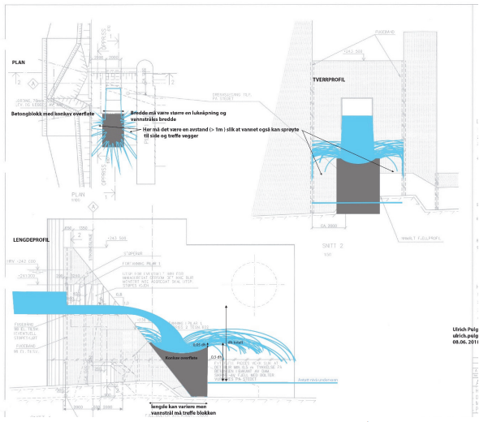
Figure 3: Technical details of the deflector installed at Tjurrmo dam at Brokke HPP in Otra, Agder [2].
REs has been used for long times. The presented setup, as shown in Figure 4, was designed and tested numerically and experimentally by Alden Research Laboratories, and installed at Cabinet Gorge Dam in Idaho and the Boundary Dam in Washington [9], [10].
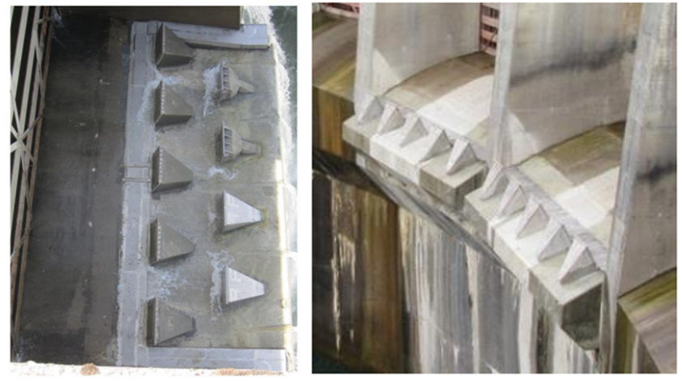
Figure 4: Spillway bay modification developed by Alden Research Laboratories for Cabinet Gorge Dam [10].

Intakes
High-head power plants, which are common in Norway, can typically have a large reservoir with the main intake and several secondary intakes in smaller catchments. The secondary intakes have a large seasonal variation of flow and will typically utilize water from snow melting during spring and wet periods during autumn. Figure 6 shows the layout of a typical shaft of a secondary intake.
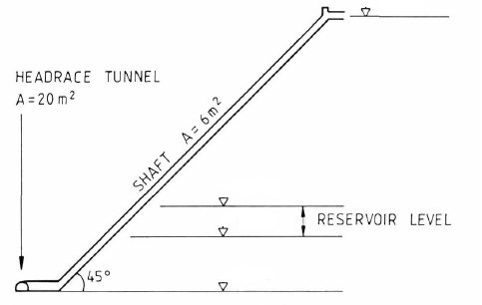
Figure 6: Sketch of a typical shaft at secondary intake in a HPP.
In Norway, the most common cause of supersaturated water is air entrainment from secondary intakes into the main tunnel [2]. The main intake of power plants with a reservoir is normally not a concern regarding generation of supersaturated water, as the actual intake is located quite deep. Supersaturation from secondary intakes will be described more in detail in Chapter 4.
High-head HPPs in Austria typically have a different layout, due to both topography, rock quality and different design philosophies. The secondary intakes are normally connected to the main reservoir through an inclined tunnel. By not connecting the secondary intakes directly to the headrace tunnel with a steep shaft, the risk of air entrainment and supersaturation is greatly reduced.

Trash-racks
Blocked trash-racks can contribute to the elevated air entrainment through intakes as reported by Pulg et.al from Hommelfoss HPP in Matreelva [2]. This was especially a problem during spring and fall, when ice and leaves were blocking the trash-rack. The solution to this particular case was to install a trash-rack cleaner which automatically operated upon reaching a pre-determined head-loss value at the trash-rack [2]. Alternatively, the intake may be converted into submerged solution.

Turbines

Pelton
Pelton turbines are very effective for degassing the supersaturated water as the nozzles discharge at atmospheric pressure. If a planned hydropower project with secondary intakes has a choice between a Francis and a Pelton turbine (if technically and economically equal), a Pelton turbine would be preferred. It should be noted, that the outlet from a Pelton turbine can entrain some air in the outlet channel and lead to a moderate supersaturation, even at atmospheric pressures. TDG of 105-110% have been measured at HPPs with atmospheric pressure at the outlet [2], [11]. Moreover, lab studies report that when the outlet shaft is pressurized, Pelton turbines can give rise to supersaturated water, with measured TDG of 150-160% [12].

Francis
At the turbine, the pressure of the water will decrease as the energy from pressure and velocity is converted into mechanical energy in the runner. Supersaturated water will degas when reaching zones with lower pressure. The lowest pressure is just at the outlet of the runner, at the top of the draft tube, where the pressure can be below atmospheric pressure. Hence, the draft tube triggers degassing, even if water pass through in less than a second. For small and moderate levels of TDG the degassing takes place only in the top part of the draft tube, while the air will dissolve again when reaching the bottom of the draft tube where the water is under-saturated with regard to the ambient pressure. For higher values of TDG, the degassing process can take place over a longer part of the draft tube because the zone of local supersaturation is longer. With high levels of TDG (above 200%), supersaturated water will degas in the whole draft tube, but not enough to reach equilibrium at the draft tube outlet [13].
Aeration of Francis turbines is also a common method to increase draft tube pressure and dampen draft tube pressure fluctuations and add air to undersaturated water. Air at atmospheric pressure is typically admitted through the draft tube wall. The admitted air will dissolve and increase the level of dissolved air. Inserting pressurized air at the runner inlet is not a common method [14].
Different hydropower operations can lead to supersaturation too, as revealed for instance from Australia and Canada. In some of the HPPs causing supersaturation the main reason for high TDG levels were linked to air injection at the turbine units to increase stability or to prevent cavitation at the units [14]. Pulg et.al found that aeration of a Francis turbine caused supersaturation in Hellandsfoss power plant, with TDG of approx. 112-117% for part load operation of the turbine [2].

Kaplan
Although Kaplan turbines are usually not associated with supersaturation, one case has been reported with air injection at the turbine in the early 70s. Air admission is also a common method to increase draft tube pressure and dampen draft tube pressure fluctuations in Kaplan turbines, but it needs to be operated sufficiently, to avoid threatening aquatic life forms [15].

Bypass and outlet sections
For both Matre and Rygene HPPs, the source of supersaturation was air entrainment in steep shafts in bypass sections past the power plant [13]. This is the same process as for air entrainment in secondary intakes, which will be closer described in the following section.
As described in the previous sections, air can be dissolved in the water after the turbine outlet depending on the pressure, depth of the outlet tunnel and turbulence level. However, due to relatively low pressure, the supersaturation will not reach extreme levels and water which is already supersaturated will start the degassing process, depending on the relative saturation. One way to degas supersaturated water in the outlet tunnel, is to keep the small degassing bubbles in the water to allow further diffusion of dissolved air through the bubble surface. Like the conditions in the intake shafts where high turbulence contributes to supersaturation, it can facilitate effective deaeration in the outlet section. High turbulence will lead to an effective mixing of water and entrained air in the outlet to keep bubbles suspended in the flow, thus allowing more time to the diffusion process. Therefore, a shallow outlet tunnel with a high water velocity will be an efficient measure and effective in terms of degassing the supersaturated water due to lower hydrostatic pressures and higher turbulence levels. However, friction losses are higher in such a tunnel which will contribute to additional head loss of the system.

Secondary intakes

Background
Hydropower development in Norway started from the early 1900 and was greatly intensified to meet increased electricity needs in the years following Second World War. Blasting was the conventional method for constructing tunnels and shafts, and thus the cross-sectional areas of the shafts were relatively large. With the developments of tunnel technology, drilling of shafts became more common from 1960-70. With the drilled shafts, the cross-sectional area and the friction of the shafts of secondary intakes were both reduced. Thus, the water velocity in the shafts was higher, which increased the risk of supersaturation.
The first cases of supersaturated water from HPPs in Norway were reported in the 1970s. In 1972 there were reports on observation of dead fish in fish farming installations close to the outlet of Matre HPP in Masfjorden. In 1978 there were registered cases of dead fish in Nidelva downstream of Rygene HPP [16] and in fish farming installations close to Tafjord K4 HPP. For all three cases, closer investigations of the issue concluded that the cause of supersaturation was air entrainment in steep shafts [13].

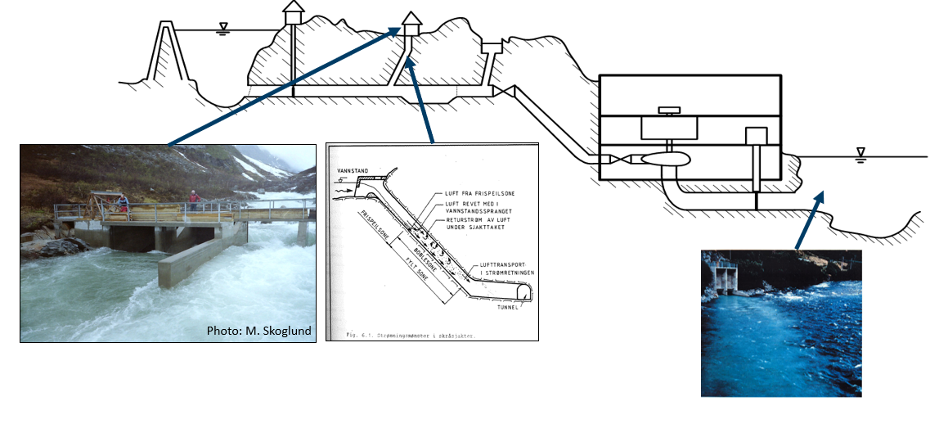
Figure 7: Overview of supersaturation generated in high-head HPPs
The Norwegian Hydrodynamic Laboratories (NHL) were in charge of many of the investigations on behalf of the HPP owners and the authorities. For instance, at the Tafjord K4 HPP, a secondary intake was identified as the source of supersaturation after a series of measurements and laboratory tests. In another case at Rygene HPP, field measurements identified that the source of the supersaturated water was the water diversion through a bypass shaft passing the power station, releasing water with high TDG levels directly to the watercourse downstream [13].
On the background of the known cases of gas supersaturation, several reports were published both by researchers at NHL and national committees. The reports described the physical process of generating supersaturated water, the main parameters affecting the process and possible technical solutions to reduce or eliminate the problem [12], [13], [17], [18], [19]. The research projects were summarized in a report with new guidelines for design of secondary intakes in 1986 [20].

Air entrainment in secondary intakes
During flood situations, with a large flow rate in the secondary intakes, air is entrained in the turbulent flow in the shaft and will dissolve in the water at higher hydrostatic pressures through a diffusion process. This will be transported through the tunnel system and the turbine. The supersaturated water will start the degassing process after passing through the turbine where the pressure lower but, depending on the degree of supersaturation, the water can still be supersaturated when reaching the outlet of the HPP with atmospheric pressure. With a large run-off to the secondary intakes, the HPP can run mainly on water from these intakes and partly even use the water to fill up reservoirs.
Secondary intakes are typically constructed as a shaft down to the headrace tunnel. In the partly filled zone of the shaft, the water flow will have a free surface until reaching the fully filled zone of the shaft with a hydraulic jump. The level of the transition between partly filled and fully filled shaft is determined by the hydraulic pressure line of the system, which depends on the water level in the main reservoir and the pressure loss in the headrace tunnel. In the turbulent conditions of both the free surface flow and the hydraulic jump, air will be mixed into the water as shown in Figure 8.

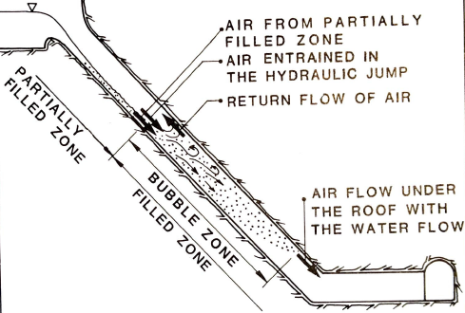
Figure 8: Definition of flow situations in shafts [18].

Partially filled zone
The flow can be characterized as an accelerating free-surface flow in the upper part of the partially filled zone. Following the acceleration phase, vortices from the turbulent boundary layer formed at the bottom and walls of the shafts cause air to be mixed into the water flow. This mixing process will increase down in the shaft until reaching a limit [12].
The location of the hydraulic jump between the free-surface flow in the partially filled zone and the filled zone is defined by the hydraulic pressure line of the system.

Fully filled zone
The critical part of the fully filled zone is defined as the bubble zone, as shown in Figure 9. The length of the bubble zone is given by the water velocity in the flow direction in relation to the rising velocity of the bubble. The length of the bubble zone increases with the flow rate. The first part of the bubble zone, a transition zone, depends on the water velocity of the partially filled zone of the shaft, while the second part of the bubble zone depends on how long it takes for a bubble to reach the roof of the shaft.
Previous research reports from NHL give an indication of the possible levels of TDG in the bottom of the shafts. For every 10 m WC increase of pressure, 2.5 volume-% of air can be dissolved in the water. If 2.5 volume-% of entrained air dissolves in the water, the oversaturation will be 100 % (200 % TDG). Hence, you can reach a supersaturation of several hundred percent if a substantial amount of air is entrained into a steep shaft and pressurized [13]. Thus, the limiting factor for the maximum theoretical limit of supersaturation will depend on the extent of the bubble zone in the shaft and the resulting hydrostatic pressure at that location.
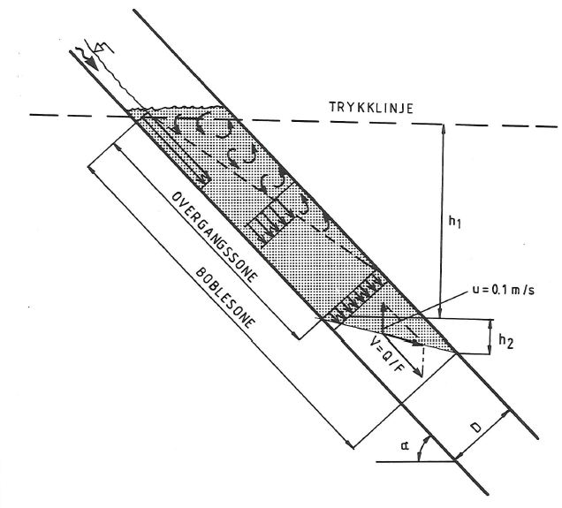
Figure 9: Schematic of transition zone and bubble zone of shaft [20].
The transition zone ends where the velocity profile of the fully filled shaft is uniformly distributed. The length of this plunge zone can be estimated by the following equation [15].
$$\frac{L_{j}}{d_{1}}=4.0*{(F_{1}-1)}^{1.05}$$
L_{j}: Length of transition zone
d₁: Depth of flow in front of the hydraulic jump
F₁: Froude number in front of the hydraulic jump
The length of the second part is given by the water velocity of the filled part of the shaft and the rising velocity of the bubble. The distance for a bubble to travel from the bottom to the roof of the shaft is given by:
$$\frac{h_{2}}{D}=\frac{v*\sin{α}-u}{u*\cos{α}}$$
v: Velocity of water in filled cross-section
u: Rising velocity of bubble
α: Shaft angle

The rising velocity of bubbles depends on the bubble size and shape and will be an estimation, typically 0.1 - 0.2 m/s [21].
In addition to supersaturation of water, the air entrainment in secondary intakes may lead to severe air blow outs. Whereas supersaturated water is generated from air bubbles that are dissolved in the water, air blow outs from secondary intakes may occur when free air bubbles are accumulated as pressurized air pockets in the tunnel system. This was also a motivation for the research on optimal design of secondary intakes, as several incidents of blow-outs have been reported [20]. In order to avoid accumulation of air in potentially dangerous air pockets in the tunnel system, the air must be able to return up the shaft. The geometry of the shaft and water velocity are also important factors to allow air return in the shaft [22], [23].
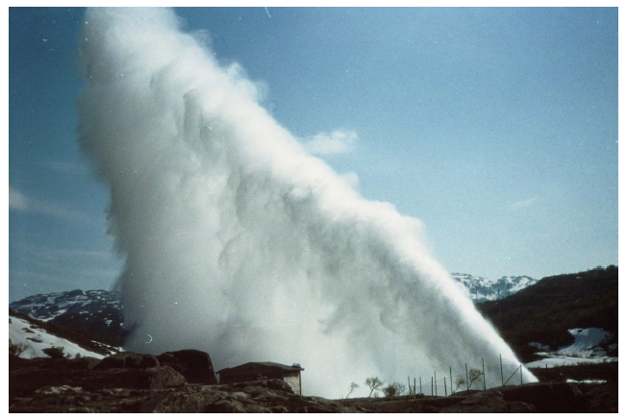
Figure 10: Air blowout in Holmaliåna secondary intake, Ulla Førre. Photo by Statkraft [22].

Guidelines for design and construction
Based on the research carried out at NHL in the 1980s, guidelines for the design and construction of secondary intakes were published by the "Committee for secondary intakes" in 1986 [20]. These guidelines are still common practice [21]. The guidelines are focused on enabling air return in the shaft, by reducing the flow velocity to allow air bubbles to rise before being pressurized and allow air to return to the surface through the shaft. This contributes to reduce the risk of both supersaturation and blow-outs of accumulated air pockets.
The report by the "Committee for secondary intakes" highlights the following factors as the most important contributors to air entrainment in existing HPPs [20]:
- Unfavorable inlet geometry of secondary intakes
- Steep and narrow shafts from the secondary intake to the main tunnel
- High water velocity in the shafts, due to high flow rate in flood situations, enhances turbulence and mixing of air and water.
- Water with suspended air bubbles is transported down in the tunnel system to areas with high hydrostatic pressure and the air will dissolve in the water.
Precautions to avoid supersaturation from secondary intakes are most practically implemented at the planning and design stages of new power plants and secondary intakes. The following methods can be considered to avoid air entrainment in secondary intakes at the planning stage [21]:

Shaft geometry
- Avoid steep shafts from secondary intakes to the main tunnel (well below 45° [13])
- Larger cross-sectional area of the shaft to reduce flow velocity

Inclined tunnel
- Construct an inclined tunnel from the secondary intake to the headrace tunnel instead of a steep shaft. An inclined tunnel has a larger cross-sectional area and thus a lower water velocity, both for the free-surface flow and the filled part which reduce the air entrainment.
- If possible, use a transfer tunnel from the secondary intake to the reservoir instead of a shaft directly on to the headrace tunnel. Supersaturated water will be diluted in the reservoir.

Submerged intake
- If possible, the intake level of the shaft should be located where the shaft would be fully filled for a dimensioning flow situation.
- Locate the secondary intake in a small pond or reservoir in connection to the river, with the same level as the main reservoir to have a submerged intake. However, this solution is highly sensitive to the location of the pressure line and only possible if there are small changes of the water level in the main reservoir
- Use a valve or gate at the bottom of the shaft to achieve a controlled submerged intake and filled shaft

Mitigation measures for existing hydropower systems with secondary intakes
As previously mentioned, the measures to prevent supersaturation are most practically implemented at the construction phase of the HPP. However, there are solutions for existing HPPs that are based on previous research [13], [17], [24], [12], [25]. Mitigation measures for the tunnel system, operational measures and the outlet will be presented in the following section.
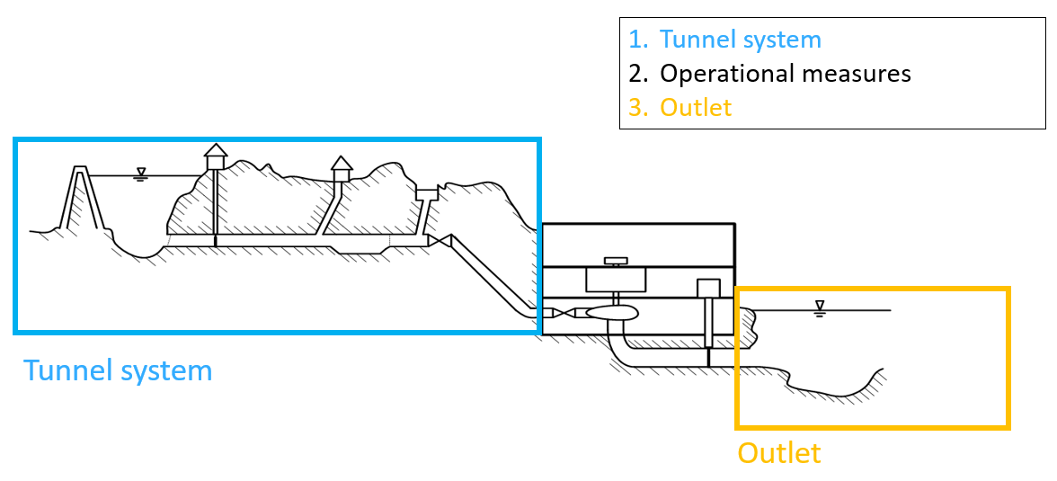
Figure 11: Categorization of mitigation measures for supersaturation from high-head HPPs
The following methods can be considered to reduce TDG supersaturation:
Tunnel system/secondary intake | Operational measures | Outlet
Reduce flow rate | Change to Pelton turbine | Shallow outlet tunnel
Larger cross-sectional area | Dilution of water | Ultrasound degassing*
Energy dissipators | Dilution and degassing in reservoir | Adding air bubbles*
Inclined tunnel | Adjust production flow | Weir or sprinkler system [20]
Controlled shaft water level |  | Discharge in deep lake, reservoir or pool
Buffer reservoir in front of secondary intake |  | Enhance degassing in river by increased roughness, ground sill, deflectors
Vacuum gate at intake** |  | Real time monitoring of TDG to adjust production flow
Utilize head in shaft with a small HPP
*Not proven in the field, research on upscaling ongoing (DeGas)
** Works only part of the time

Mitigation measures at the secondary intakes

Reduce flow rate
The flow rate in the secondary intake can be limited to ensure a sufficiently low water velocity to avoid air entrainment. This can be done by creating an upstream buffer reservoir to reduce the magnitude of the flood peaks. Another option is to transfer parts of the flow to an adjacent secondary intake with better capacity. The secondary intake can also be closed or partly closed, which would result in excess spill in flood situations [23].

Larger cross-sectional area
By reducing the water velocity, the extent of the bubble zone in the shaft will be reduced. Expanding the cross-sectional area of the shaft will reduce the velocity, but some air will still be entrained. An example from evaluations of expansion of the shaft at Tovatna intake in Driva showed that expanding the cross-sectional area from 6 to 30 m² reduced the calculated level of TDG from 350% to 180% for a flow of 10 m³/s [20]. Hence, the saturation level was still high, but significantly reduced.
In addition to the actual construction costs for widening an existing shaft, the cost of production loss during the construction period must also be taken into account. The cost of lost production will often make this alternative unfeasible [23].

Energy dissipators
To further reduce the saturation level, the water velocity in the partly filled shaft must be reduced to minimize the extent of the bubble zone. This can be done by physical obstacles like pillars and stairs. A stair solution was designed for a secondary intake for Eikelandsosen HPP, which was constructed in the mid-80s and in operation from 1986. The shaft was designed to function both as a secondary intake and a surge shaft and would thus be very long [26].
The cost of construction in addition to the cost of lost production will also make this alternative unfeasible [23].

Inclined tunnel
Compared to a steep shaft, an inclined tunnel from the secondary intake to the headrace tunnel would result in a larger cross-section and a lower water velocity in the fully filled section. The feasibility of this alternative will of course depend on the topography and geological conditions, necessary slope and curve of tunnel which may lead to high construction costs. When constructing a new tunnel, most of the construction work can be carried out without interfering with the power production.
Statkraft is constructing a new inclined tunnel for the secondary intake Holmaliåna in Ulla Førre, which has a previous history of air entrainment and dangerous blow outs.

Controlled shaft water level
A valve or gate can be installed at the bottom of the shaft to elevate and control the water level, as shown in Figure 12. Thus, the location of the plunge zone can be controlled or the shaft can be fully filled with a submerged intake. The necessary construction work for this solution is extensive and associated costs are high.

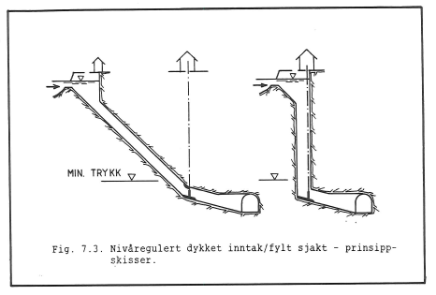
Figure 12: Submerged intake with a filled shaft, due to the valve at the bottom of the shaft [20].

Buffer reservoir in front of secondary intake
Larger pools or smaller reservoirs placed in front of the secondary intakes can reduce oversaturation. The benefits from this solution that it provides an actual buffer zone before the usually rapid water from creek intakes is being diverted into the shaft and the magnitude of the peak flows during flood periods can be reduced. Still air entrainment may occur in the shaft if not designed properly.

Vacuum gates
The vacuum gate is constructed to limit the air access to the shaft to avoid air entrainment from the water-air interface in the shaft. The gate is always submerged in the water and is self-regulating by a customized floater. The air that already is in the shaft when the gate is put into operation will eventually be dissolved in the water in the shaft, and then an equilibrium close to vacuum is reached. This transitional phase can take a few hours, depending on the flow, and air will be entrained in this period [2]. However, when equilibrium is reached and the vacuum gate is fully effective, the vacuum gate will function as long as the vacuum is not broken. Recent long-time monitoring from the SUPERSAT project shows that biologically relevant TDGS may nevertheless occur since it takes time to establish the vacuum and since it can be broken regularly at certain water levels.
A vacuum gate valve was installed at Tovatn secondary intake of Driva HPP in 1986, as the first of its kind. Trønder Energi installed another vacuum gate valve at the secondary intake Otta, also in Driva HPP. Tafjord power company has also installed such a vacuum gate at Muldal secondary intake in Tafjord K4 HPP.

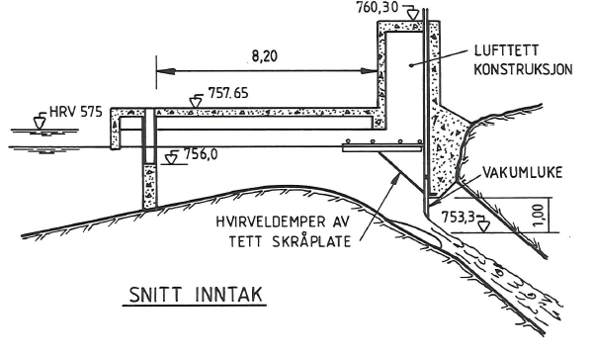
Figure 13: Vacuum gate as installed on Tovatn secondary intake [20].
Bubbles that are already in suspended the water as free air, not dissolved air, will still be transported by the water into the shaft. Due to this, the Tyrol intake in Otta river in Driva HPP was modified to have calmer water entering the shaft [28] which is shown in Figure 14. The intake direction is opposite to the flow direction of the river, which leaves time for free air bubbles to rise to the surface before entering the shaft as can be seen to the left in Figure 14.

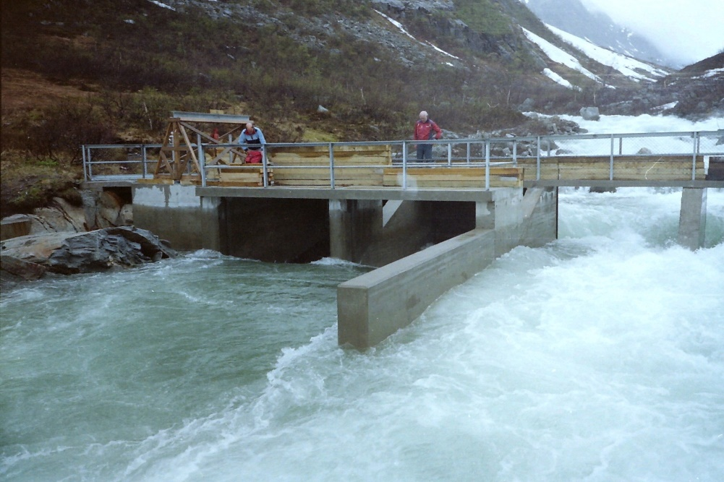
Figure 14: Intake at Otta secondary intake in Driva. modified Tyrol intake [28].
For an optimal function of a vacuum gate, it is also important to avoid a vortex at the gate, which can pull air into the water at the gate opening. This was solved by a tilted plate as a guide wall, as can be seen in Figure 15 for drawings for the vacuum gate at Tovatn secondary intake.
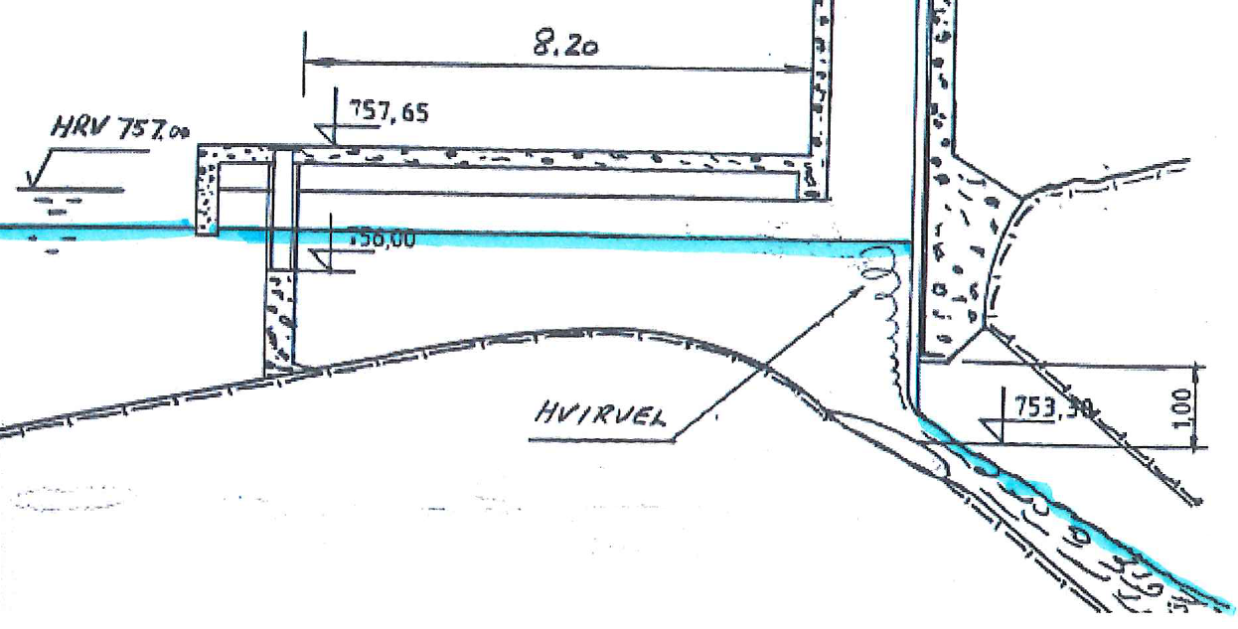
Figure 15: Vortex formation at gate opening [28]

Utilize head in shaft in a small powerplant
Secondary intakes with a relatively high runoff and head could potentially be utilized for a small HPP. For such a solution, a small reservoir and a submerged intake are needed. This was considered as a solution for the Tovatna secondary intake in Driva HPP, but a vacuum gate was found to be a better technical and economical solution [20].

Mitigation measures at the main intakes
Pulg et al. [2] describe three cases with severe TDGS and fish kills were caused by air entrainment at the main intake. One case was Førsvatnet, Kjelavassdraget, where the intake was not placed deep enough in the reservoir and could directly entrain air at low water levels. The second and third case were Myster HPP (Eksovassdraget) and Hommelfoss HPP (Matrevassdraget), where clogged intake screens led to a significant head loss and air entrainment at the intake screen.

Placement
Air entrainment at regular main intakes can be avoided by placing the intake so deep that it will not be able to get in contact with air (directly or by vortex) while the power plant is running.

Screen cleaner
Clogging can be avoided by sufficiently dimensioned and maintained screen cleaners.

Alert system
At Myster HPP a logger was installed and connected to the plant's steering system. When TDGS occurred the power plant could reduce production flow and thus avoid acute fish kills as well as identify the cause and potentially clean the intake screen.

Operational measures

Pelton turbine
A Pelton turbine is very efficient for degassing supersaturated water. Where technically possible, using a Pelton turbine instead of a Francis turbine would be preferable. However, a Pelton turbine with a pressurized outlet could cause supersaturated water, as presented in physical experiments [12].

Dilution of water
Operation of the power plant during flood situations is essential, where the majority of the water may originate from the secondary intakes for some HPPs. For part load operation with a flow corresponding to the maximum flow capacity of the secondary intakes, the resulting gas supersaturation at the outlet will be critical. On the other side, if the power plant is operated at full load, the supersaturated water from the secondary intakes will be diluted with water from the main reservoir before reaching the turbine. Thus, the operator has a choice between small amounts of water with a high level of supersaturation or large amounts of water with a lower level of supersaturation. The steering can be based on the total outlet TDGS level and its environmental impact, i.e. flow conditions in the river downstream, water depth, dilution with residual flow outlet to a lake etc. [20]. This mitigation measure requires steering systems which can separate secondary intake water from main intake water. These are often not existing.
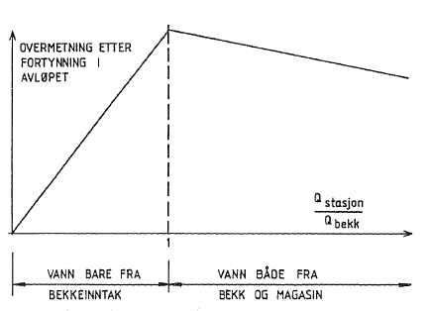
Figure 16: Resulting supersaturation at the station outlet for different operation [20].

Dilution and degassing in reservoir
Another possibility is dilution and aeration in the main reservoir. This requires a stop in production, whereupon water from the secondary intakes will flow into the main reservoir where it will be diluted and may be aerated. In a stratified reservoir however, aeration will be very limited to not existing if TDGS is discharged into the hypolimnion.
The measure may reduce the level of supersaturation, but the tunnel will be filled with supersaturated water and thus lead to TDGS when emptied. . The measure may have strong economic consequences for the power plant operators [20].
This method was tested at Driva HPP and found to be an effective solution [19], but the cost of lost production may be critical and larger than the constructional mitigation measures.

Mitigation measures in the outlet

Shallow outlet tunnel
A shallow outlet tunnel with relatively high water velocity will be an efficient measure for degassing after the turbine outlet (2). The design will reduce or avoid the solution of air in the tunnel. Additionally, the increased friction and turbulence will enhance deaeration processes. A drawback with a shallow outlet tunnel is a potentially increased head loss or wide dimension.

Ultrasound degassing
Ultrasound introduces an acoustic pressure field where the supersaturated water will cavitate and form small vapor bubbles when experiencing pressure lower than the vapor pressure. The bubbles will grow when the pressure is increased, when more dissolved gas will diffuse into the bubbles. The idea of using ultrasound in the power plant outlet was evaluated in the 1980s [20]. A current research project, DeGas, is studying the possibility of using ultrasound technology at the outlet for degassing of supersaturated water [29]. Possible challenges that the DeGas project will address are up-scaling of the technology to reach the capacity of the power plant flow rate and the power demand to operate such an installation.

Adding air bubbles
Adding bubbles to the water can speed up the degassing process, when dissolved gas will diffuse into the bubbles, rise to the surface and vent to atmosphere [30], [31]. This solution requires many small bubbles suspended in the flow to effectively degas, and the bubble size and the up-scaling need to be researched. This method is also tested in the DeGas project.

Tailrace with weirs or sprinkler system
The use of a multistage weir overflow or a sprinkler system can be used to degas supersaturated water. Weir installations are used in thermal HPP for degassing, but with much lower flowrates than in a HPP. For flowrates in a HPP, this solution will require large structures that results in high head loss [18] and will not be feasible.
An experiment with a weir in the tailrace channel was carried out in Tafjord K4, but no effect on the degassing was found [18].
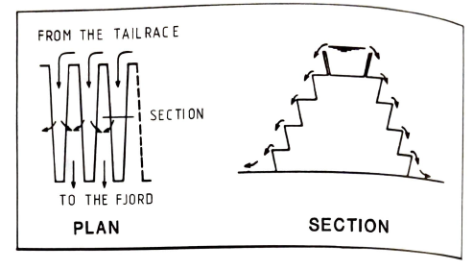
Figure 17: Weir construction for the degassing experiment carried out at Tafjord K4 [18].
Another solution is to utilize a flat area close to the HPP where the water will be directed for situations with supersaturation as an extended outlet. Here the degassing process would be enhanced by facilitating shallow water flow with rocks and vegetation as a sprinkler system. This solution will of course depend on the HPP location and landscape [13].

Downstream reservoir or pool
Where possible, directing the supersaturated water to a downstream reservoir or lake could be a solution to avoid supersaturated water entering shallow river habitats where it has most severe biological impacts. By increasing residence time of the flow, degassing processes become more efficient.

Enhance degassing in river
Degassing in rivers normally take place in shallow parts with waterfalls, turbulence and large roughness of the riverbed. Hence, adding artificial elements to reinforce these conditions would be beneficial in a similar way as presented for dam spills in Section 3.2. Pulg et.al propose introducing a weir with a drop and large rocks with a diameter of 1-2 m in the river to increase friction and turbulence [32].

Summary
Supersaturated water from hydropower installations most commonly arise from either spill water over high dams or from secondary intakes with steep shafts in high-head HPPs. Air entrainment at main intakes has also been observed in some cases, usually linked to clogging of intake screens. To reduce the water velocity in dam spillways, mitigation measures like flow deflectors or roughness elements can be implemented.
The most common cause of supersaturated water in Norwegian HPPs are secondary creek intakes during situations with high run-off. Air is entrained in steep and narrow shafts, dissolves in the water under higher hydrostatic pressures and cause supersaturation in the river after passing through the HPP. The entrained air can also accumulate in large air pockets if not able to return up the shaft, which can cause highly damaging blow-outs at the secondary intake. Several research projects have looked at air entrainment in shafts in secondary intakes, and the main conclusion is that the water velocity is the most important factor causing air entrainment in shafts [20]. In addition, maximum level of TDG is given by the hydrostatic pressure at the bottom of the plunge zone in the transition between free surface flow and the fully filled shaft.
Precautions to avoid supersaturation from secondary intakes are most practically and economically implemented at the planning and design stages of new power plants and secondary intakes. The following factors are important to avoid air entrainment in secondary intakes at the planning stage:
- Design a sufficiently large cross-sectional area to reduce flow velocity
- If possible, construct an inclined tunnel (with less than 45°) from the secondary intake to the headrace tunnel or the reservoir instead of a steep shaft
- If possible, use a submerged intake
For the case of mitigation measures on existing HPPs, the assessment will be site specific. The conditions at the intake, accessibility of the intake, hydrology and runoff, shaft geometry, and conditions at the outlet shall be considered. It is recommended to evaluate all factors and mitigation measures together with the ecological effects and economic aspects of investment costs and loss of production, either from reduced flow from secondary intakes or downtime during the construction phase.
The following mitigation measures can be implemented at existing secondary intake to avoid or reduce generation of supersaturated water:
- Reduce flow rate
- Larger cross-sectional area
- Energy dissipators
- Inclined tunnel
- Controlled shaft water level
- Buffer reservoir in front of secondary intake
- Vacuum gate at intake
- Utilize head in shaft with a small power plant
At main intakes:
- Submerged design
- Sufficient screen cleaning
After the outlet:
- Areation in the river by water drops over thresholds, increased roughness or deflectors
- Alert system with continuous TDG logging at the outlet
- Reducing production flow
- Dilution with residual flow
- Diverting the water into less sensitive habitats such as deeper river stretches or lakes
References
1. Harvey, H.H., Gas disease in fishes - A review, in Chemistry and physics of Aqueous gas solutions. 1975.
2. Pulg, U., et al., Gassovermetning i vassdrag - en kunnskapsoppsummering. 2018: Norce Laboratorium for ferskvannsøkologi og innlandsfiske (LFI).
3. Berg, A. Supersaturation of dissolved air in the waterways of hydro-electric power plants. Review and examples. in Underground Hydropower Plants. 1987. Oslo, Norway.
4. Weitkamp, D.E. and M. Katz, A Review of Dissolved Gas Supersaturation Literature. Transactions of the American Fisheries Society, 1980.
5. Politano, M., et al. Spillway deflector design using physical and numerical models. in 6th IAHR International Symposium on Hydraulic Structures. 2016. Portland, OR.
6. Qu, L., et al., Field observation of total dissolved gas supersaturation of high dams. Science China - Technological Sciences, 2011.
7. Yuanming, W., et al., Tolerance and avoidance mechanisms of the rare and endemic fish of the upper Yangtze River to total dissolved gas supersaturation by hydropower stations. River Research and Applications, 2020. 36.
8. Turan, C.P., M.S; Carrica, P.M. and Weber, L., Water entrainment due to spillway surface jets. International Journal of Computational Fluid Dynamics, 2007.
9. Dunlop, S., G. Paul, and K. Pate, Partnering to mitigate TDG through spillway modifications, in Hydro Review. 2014. p. 16-24.
10. Dunlop, S., I. Willig, and G. Paul. Cabinet Gorge Dam Spillway modification for TDG Abatement - Design, Evolution and Field Performance. in 6th IAHR International Symposium on Hydraulic Structures. 2016. Portland, OR.
11. Pulg, U.V., K. W.; Velle; G, Stranzl, S., First observations of saturopeaking: Characteristics and implications. Science of the Total Environment, 2016.
12. Berg, A., Luftinnblanding, overmetning og avlufting i kraftverkssystem. 1983, NHL.
13. Berg, A., et al., Overmetning av oppløst luft i vann fra kraftverk - årsaksforhold, skadevirkninger og mottiltak. 1983, Norges hydrodynamiske laboratorier (NHL).
14. Dörfler, P.K., Design criteria for air admission systems in Francis turbines. Proceedings of IAHR Symposium, Montreal, Canada, 1986, 1986.
15. MacDonald, J.R. and R.A. Hyatt, Supersaturation of nitrogen in water during passage through hydroelectric turbines at Mactaquac Dam. Journal of the Fisheries research board of Canada, 1973.
16. Heggberget, T., Effect of supersaturated water on fish in the River Nidelva, southern Norway. Journal of Fish Biology, 1984.
17. Blindheim, B., et al., Problemer med luftovermetning i vann fra kraftverk. 1983, Komiteen for undersøkelse av gassovermetning.
18. Tekle, T., Supersaturation of dissolved air in the waterways of hydro electric power plants - Casual relationships, detrimental effects and preventive measures. 1984.
19. Berg, A., Luftovermetning ved Driva kraftverk. Utredning i forbindelse med revisjonsskjønn. 1985, NHL.
20. Stokkebø, O., Bekkeinntak på kraftverkstunneler - Sluttrapport fra Bekkeinntakskomiteen. 1986, Vassdragsregulantenes forening.
21. Guttormsen, O., Vassdragsteknikk II. 2013: Akademika Forlag.
22. Gjerde, R.U., Luftproblemer i bekkeinntak. 2009, NTNU.
23. Skoglund, M.L., Leif; Bjertnes, Trond Markvad; Jerkø, Jostein. Air accumulation in hydropower tunnel. in Hydro 2016. 2016.
24. Berg, A., Overmetningsproblemet ved Tafjord K4. Målinger på anlegget våren 1981. 1981, Norges Hydrodynamiske Laboratorier.
25. Berg, A., Modellforsøk av tofase luft-vannstrømning i bekkeinntakssjakter. 1986, NHL.
26. Berg, A., Eikelandsosen kraftverk. Tiltak mot luftovermetning. 1983, Norges Hydrodynamiske Laboratorier.
27. Berg, A., Air entrainment and supersaturation of dissolved air in a shaft under atmosperical and reduced pressure conditions. Journal of hydraulic research, 1992.
28. Skoglund, M. Luftinnblanding i bekkeinntakssjakter - løsning ved vakuumluker? in Fiskesymposiet 2016. 2016.
29. Rognerud, M.E., et al., How to avoid total dissolved gas supersaturation in water from hydropower plants by employing ultrasound. Journal of physics: Conference series, 2020. 1608.
30. Zhang, Y., G. Zhou, and A. Prosperetti, Bubbles as a Means for the Deaeration of Water Bodies. Journal of Environmental Engineering, 2017.
31. Ou, Y.L., R; Niu, J; Feng, J; Pu,X, The promotion effect of aeration on the dissipation of supersaturated total dissolved gas. Ecological Engineering, 2016. 95.
32. Pulg, U., et al., Gassmetning i Otra nedenfor Brokke 2016-2017 og muligheter for avbøtende tiltak. 2018: Uni Research Miljø.

