Phase Transformations from Quartz to Cristobalite
Karin Fjeldstad Jusnes¹, Merete Tangstad¹, Eli Ringdalen²
¹ Norwegian University of Science and Technology
² Sintef Materials and Chemistry
Contact: karin.jusnes@ntnu.no, +47 99167976

Keywords: Quartz, Cristobalite, Phase transformations, Silicon production, XRD

Abstract: Two quartz types used in the silicon and ferrosilicon industry were heated to temperatures of 1600 and 1700 °C. The parameters varied were the temperature and the holding time at maximum temperature. The amount of quartz, cristobalite and intermediate amorphous phase were measured using XRD and the internal standard method. Type P showed a much larger ability to transform to cristobalite at lower temperatures than type A. Type P had a larger amount of alkali and alkaline earth impurities. This could have enhanced the transformation to cristobalite. For quartz type A the amount of cristobalite was larger at 1600 °C than 1700 °C. This can be also be seen for some of the samples of type P at shorter holding times.

Introduction
To produce silicon and ferrosilicon in a submerged arc furnace, quartz and various carbon sources are added at the top of the furnace. The temperature is increased by electricity supplied through three carbon electrodes and energy from chemical reactions. As the raw materials descend in the furnace, they will start to react. The overall reaction equation for the process is given in Reaction 1.
SiO₂(s) + 2C(s) = Si(l) + 2CO(g) | (1)

The quartz, consisting of mainly SiO₂, can react either with silicon, Si, or silicon carbide, SiC, according to Reaction 2 and 3 respectively. Depending on the temperature, the SiO₂ can be either solid or liquid. The temperature at the charge top is around 700 - 1300 °C [1]. In the lower part of the furnace, the temperature could be well above 2000 °C.
SiO₂(s,l) + Si(l) = 2SiO(g) | (2)
2SiO₂(s,l) + SiC(s) = 3SiO(g) + CO(g) | (3)

The SiO-gas produced in Reaction 2 and 3, will ascend in the furnace and meet the carbon added at the top. Depending on the SiO-reactivity of the carbon, Reaction 4 will take place.
2C(s) + SiO(g) = SiC(s) + CO(g) | (4)

In the lower part of the furnace, SiO-gas and SiC will react to produce liquid silicon, according to Reaction 5. The temperature has to be above 1811 °C for this reaction to happen.
SiC(s) + SiO(g) = 2Si(l) + CO(g) | (5)

Liquid silicon is tapped at 1600 °C from the side of the furnace. An illustration of a silicon production plant can be seen in Figure 1.
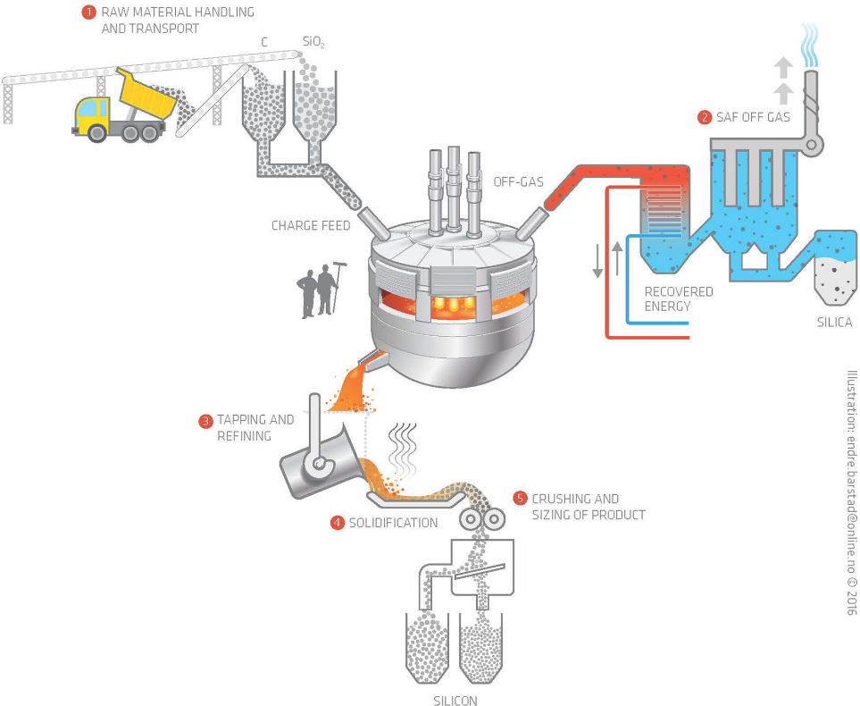
Figure 1: An overview of a silicon production plant [2].
In the production of silicon and ferrosilicon, different types of quartz are used. Their properties could influence how efficient the furnace is producing. Some of the properties that could affect the furnace operation is melting and softening temperatures, fines generation and phase transformations. In this investigation the phase transformation from quartz to cristobalite for two different quartz types are studied. The different phases may affect the reaction rates and the disintegration of quartz upon heating.
The phase diagram of silica is given in Figure 2. It shows the phases stable up to and above the melting point of SiO₂, which is 1723 °C [1]. Before the melting point is reached, several phase transformations occur at atmospheric pressure.
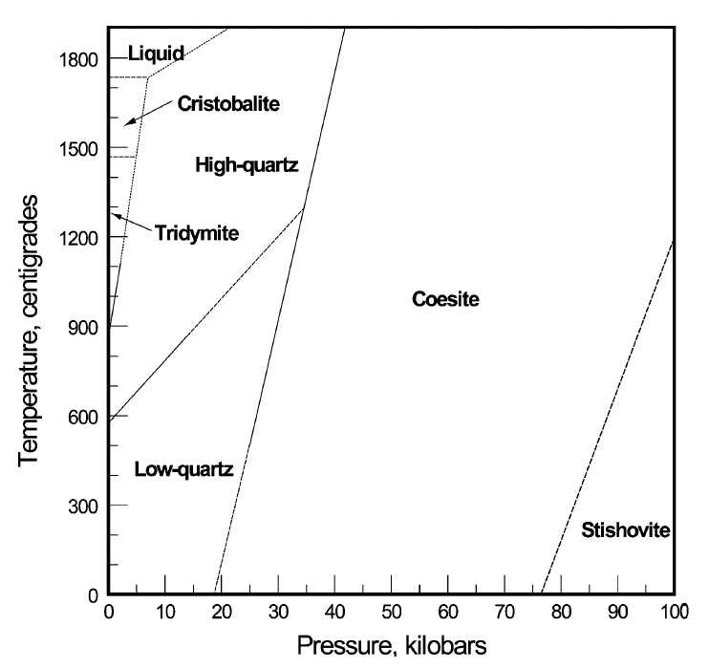
Figure 2: The phase diagram of silica [1].
Quartz is the low temperature and low pressure polymorph of silica. This makes quartz the predominant silica phase in the earth`s crust [3]. Quartz has a low and high temperature configuration called α- and β-quartz, respectively. This transformation is displacive, meaning no bonds are broken, only shifted. The energy needed for such transition is low. When β- quartz is further heated it will, according to the phase diagram in Figure 1, transform to tridymite. However, this transformation does not seem to occur in pure SiO₂. A certain amount of impurities, like alkali elements are needed for the stabilization of tridymite [4]. Therefore β-quartz will transform to cristobalite. This transformation is sluggish and will occur over a temperature interval from around 1300 °C up to the melting point of SiO₂ [5]. The transformation between these two phases is reconstructive. Which means that the bonds between the atoms are broken and rearranged. Such transformation, compared to a displacive one, is therefore more time and energy consuming. According to several studies, the transformation between β- quartz and cristobalite goes through an amorphous intermediate state [6] [7] [8] [9]. According to Presser et al. [10], the transformation from quartz to intermediate amorphous state reaches its maximum at 1677 °C. The following reaction is suggested for the transformation from β-quartz to β-cristobalite [4].
approx. 1300 °C
Quartz Transition phase Cristobalite | (6)

The mechanism of the transformation from β- quartz to cristobalite is not fully known, but several theories are presented. Marian and Hobbs [11] has presented a theory that for cristobalite to form, a third of the bonds in quartz has to break. They also suggested that nucleation point will be created throughout the quartz sample. The transformation will therefore be slow in the beginning. Also Wiik [5] suggested that the transformation would happen throughout the sample because nucleation point would form. As the cristobalite and transition phase has a lower density, crack will develop in the silica sample as the amount of quartz decreases. This would cause a very fragile sample that will easily crumble. Aasly [1] describes a study by Mitra from 1977 who presented results that indicated that the transformation from quartz to intermediate phase was boundary controlled, while the transformation from intermediate phase to cristobalite was concentration controlled.
Schneider et al. [9] has presented results, which shows that a higher amount of alkali and alkaline earth elements would catalyze the transformation from quartz to cristobalite. The explanation is that the impurities will create liquids with melting point well below the melting point of silica. These liquids will spread through the mass, and increase the diffusivity leading to more rapidly decomposition of quartz and rapid nucleation and growth of cristobalite. In the same study, they mention that smaller grain size and defects in the crystallinity will favor the transformation to cristobalite. Also Pagliari et al. [12] investigated the effect of particle size on the transformation kinetics between quartz and cristobalite. They investigated different quartz powders, and found that the ones with smallest particle size produces the largest amount of cristobalite.

Experimental
In this study two different types of quartz, used in the silicon and ferrosilicon industry, were heated in a Nabertherm LHT 04/08 rapid heating furnace to 1600 and 1700 °C. The chemical composition of each type is given in Table 1. Quartz type A is a gravel quartz, while quartz P is a hydrothermal quartz. The holding time at maximum temperature was varied. After heating, all the samples were cooled, and then milled to a powder. The milling process has been shown not to have an impact on the amount of phases in a silica sample [13]. After milling, all samples were dried at 250 °C overnight to remove water from the samples. To be able to also measure the amorphous phase with XRD, a highly crystalline spike was added to all the samples in a known amount. The method is called internal standard method, and is described thorough by Kjelstadli [8]. Back loading samples were prepared for the XRD equipment Davinci 1. Topas software was used to measure the amount of quartz, cristobalite and amorphous content in each sample. To see the variation in the XRD measurement, 3 parallels of the same heated sample were analyzed.
Table 1: Chemical composition of quartz sample A and P. All measurements are wt%.
Quartz type | Al₂O₃  [%] | Fe₂O₃  [%] | TiO₂  [ppm] | CaO  [%] | Na₂O  [%] | K₂O  [%] | MgO  [%] | MnO  [ppm] | P₂O₅  [ppm] | SiO₂ [%]
A | 0.020 | 0.0029 | 7.0 | 0.0004 | 0.0013 | 0.0028 | 0.0014 | 0.3 | <2.6 | 99.97
P | 0.026 | 0.0068 | 4.2 | 0.240 | 0.0073 | 0.0129 | 0.0013 | 37.3 | <2.6 | 99.71

Table 2 shows the details for each experiment. The same heating plan was used for two types of quartz, A and P. Further, the denotation A1 will be quartz type A with the details for experiment 1. A number after a dot indicates a second or third parallel of the experiment. All the samples were around 10 g.
Table 2: Experiment details for both quartz types.
Experiment no. | Maximum temperature [°C] | Holding time at maximum temperature [min]
1 | 1600 | 0
2 | 1600 | 120
3 | 1700 | 0
4 | 1700 | 15
5 | 1600 | 15
6 | 1700 | 30
7 | 1600 | 30
8 | 1700 | 45
9 | 1600 | 45
10 | 1600 | 60
11 | 1700 | 60

Results and Discussion
All samples were heated in a rapid heating furnace according to the information given in Table 2. It took around 30 minutes to reach 1600 °C, and around 35 minutes to reach 1700 °C. Already after 11-12 minutes, the temperature had reached 1300 °C. Most of the A samples were in one piece after heating, but appeared mechanically weaker than before heating. A typically example of quartz type A can be seen in Figure 3.
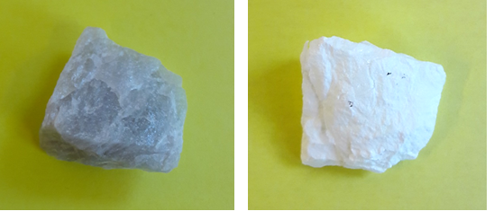
Figure 3: Sample A11 before (left) and after (right) heating to 1700 °C. The sample was held at 60 minutes at this temperature. The weight was 10.8 g, and the size of the samples are 2-3 cm.
The sample P2 before and after heating can be seen in Figure 4. All the P samples looked more or less like this after the heat treatment. They had fractured into several smaller pieces, which crumbled easily if subjected to light pressure. This is in accordance with Wiik’s [5] explanation that due to a tension in the sample because of lower density of the transition phase and cristobalite, the sample would easily crumble.
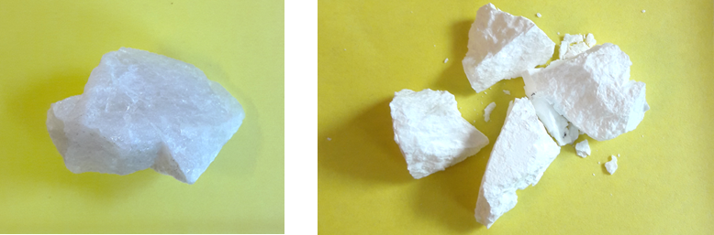
Figure 4: Sample P2 before (left) and after (right) heating. The sample was heated to 1600 °C and held for 120 minutes at this temperature. The weight of the sample was 9.7 g, and the size 2-3 cm.

The three XRD measurements performed for each sample showed that the sample variation in the XRD measurements were around 2-3% for both sample A and P for all the three phases quartz, cristobalite and amorphous phase. Clear outliers are discarded from this calculation. An example of how a XRD spectra with silica containing quartz, cristobalite and amorphous phase looks like, is seen in Figure 5. Each phase has their own fingerprint peaks. The first peaks of each type are marked. The amorphous content is calculated based on the known amount of cristobalite, quartz and spike. Figure 5 is sample A10, which had 20 % amorphous phase, 47 % cristobalite and 33 % quartz.

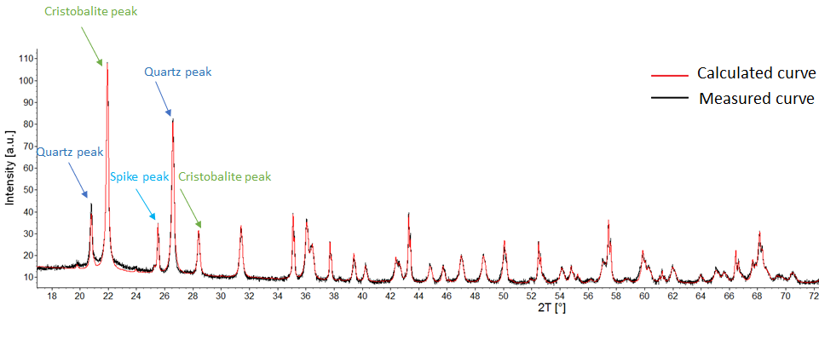
Figure 5: A XRD diffractogram from sample A10 that contains quartz, cristobalite, amorphous phase. The red line indicates how a sample containing quartz, cristobalite and spike would appear ideally

Phase transformations, type A
For sample A, the amount of phases for all the samples heated to 1600 °C are shown in Figure 6. Each bar represent the average of three XRD measurements. The first three bars labelled “0” are the same experiment done with three different lumps to check for reliability and repeatability of the experiments. As can be seen from the figure there is an overall trend with some internal variations. During heating to 1600 °C, the main part of the sample will still be quartz. It takes more than 120 minutes at 1600 °C before most of the sample is transformed to cristobalite. The amount of amorphous phase is in the area 10-20 % for all holding times up to 120 minutes. This supports the earlier studies, which suggest that the transformation from quartz to cristobalite is slow, and goes through an amorphous state.
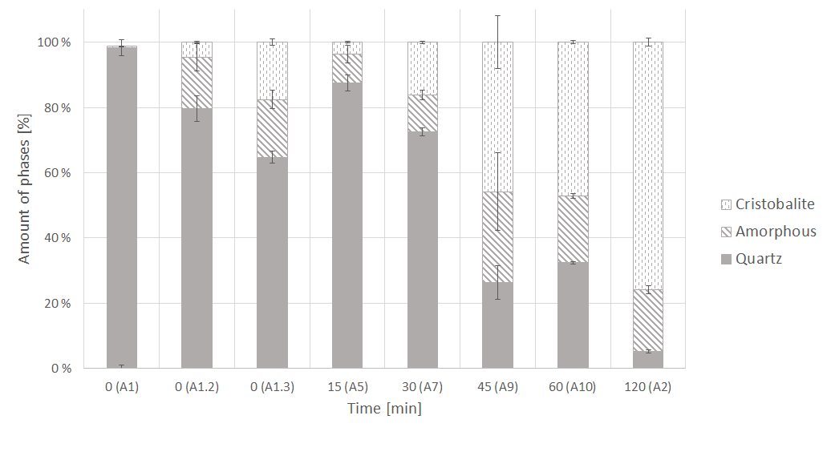
Figure 6: The amount of silica phases after heating quartz samples, type A, to 1600 °C and varying the holding time at maximum temperature.
For all the samples heated to 1700 °C the amount of the different phases are shown in Figure 7. Also for these samples a decrease in the amount of quartz can be observed. The difference from the samples heated to 1600 °C is the amounts of amorphous phase, which are larger for the 1700 °C samples. After 15 minutes holding time the amorphous content is 60-70 %, and the amount of quartz less than 10 %. The cristobalite content is around 20-30 % for holding times from 15 minutes and upwards. This could imply a faster transformation to the amorphous transition phase than from the transition phase to cristobalite. According to Presser et al. [10], the crystallization rate from amorphous silica towards cristobalite reaches its maximum at 1677 °C. After this temperature, the silica will become more and more molten. At the melting point, 1723°C, the silica will be completely amorphous (by definition), but also have a very high viscosity. The amount of cristobalite is lower for the samples heated to 1700 °C compared to the one heated to 1600 °C. One of the experiments to 1700 °C with 0 minutes holding time is very different from the two other with no quartz and 80 % cristobalite. This sample is considered an outlier. The other two samples with holding time 0 minutes are in agreement with each other.
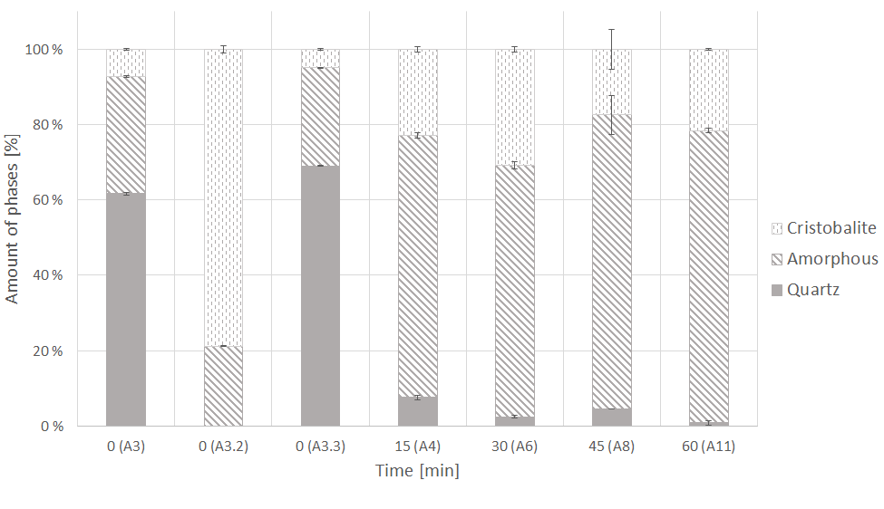
Figure 7: The amount of silica phases after heating quartz type A samples to 1700 °C and varying the holding time at maximum temperature.
Phase transformations, type P
For quartz type P, the amount of phases were somewhat different from A. In general, type P converted more easily to cristobalite. For all the P samples heated to 1600 °C, the results can be seen in Figure 8. Already with 0 minutes holding time, the amount of cristobalite is around 85-90 %. Less than 5 % of quartz is still present in all the samples. The amount of amorphous phase is also less than 5 % for nearly all the holding times. Three parallels were done for the experiment with holding time of 30 minutes.

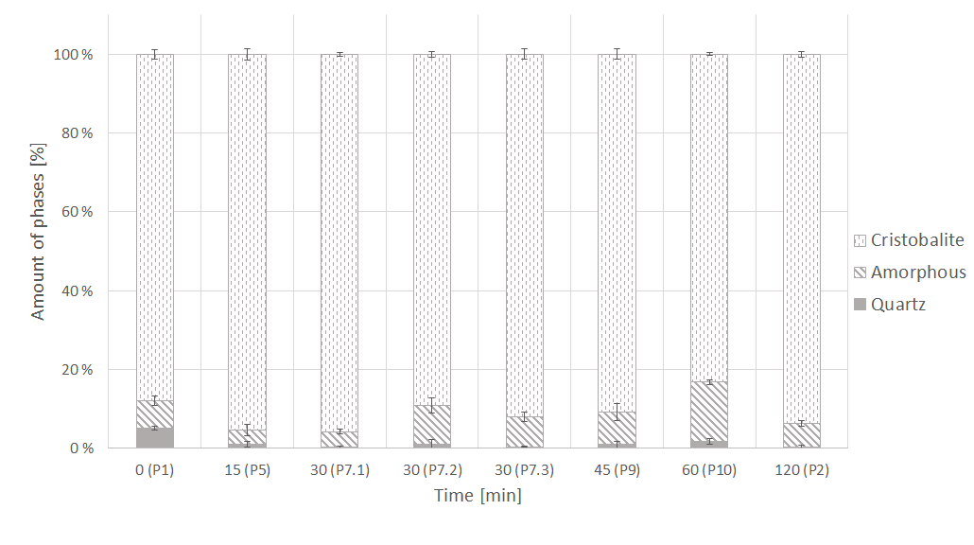
Figure 8: The amount of silica phases after heating quartz, type P, samples to 1600 °C and varying the holding time at maximum temperature.
For the P samples heated to 1700 °C, the amount of phases can be seen in Figure 9. The amount of amorphous phase is larger for the shorter holding times than the longer. This could be explained by more and more of the transition phase being transformed to cristobalite as the holding time increases as suggested by several [8] [11] [6]. If type A and P at 1700 °C are compared, type P more easily converts to both amorphous phase and cristobalite.
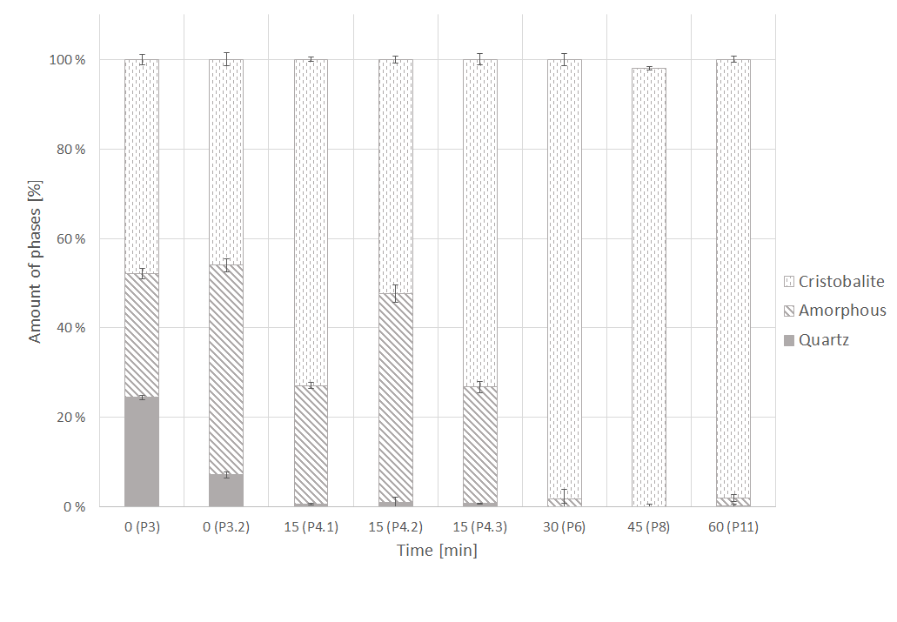
Figure 9: The amount of silica phases after heating quartz, type P, samples to 1700 °C and varying the holding time at maximum temperature.
The content of alkali and alkaline earth oxides are 0.0059 % and 0.2615 % for A and P, respectively. This could explain the considerably larger amount of cristobalite produced in type P contra A. As suggested by Schneider et al. [9], the alkali and alkaline earth impurities will speed up the transformation from quartz to cristobalite because these impurities are making diffusion easier.
The effect of the different amount of phases on the furnace performance is not fully understood. Good strength is favorable for furnace performance, and therefore it could be assumed that type A is better than type P since type P seemed to disintegrate more upon heating than type A. Any correlation between the amount of phases and disintegration has not been the main focus in this study.

Conclusion
Two different quartz types, A and P, were heated to 1600 °C and 1700 °C for different holing times at maximum temperature. The amount of phases were measured using XRD. Sample P produced a considerable larger amount of cristobalite. For heating to 1600 °C, type A had less than 10 % cristobalite while type P had up to 90 %. In general, increased temperature and holding time will increase the transformation from quartz to cristobalite. It also seems that the amount of alkali and alkaline earth impurities in the quartz could increase the transformation to cristobalite. This has to be further investigated with other quartz samples as well. Other parameter could also affect the phase transformations in silica.

Acknowledgments
This paper is published by permission of Elkem AS. The Research Council of Norway and Elkem Technology are appreciated for their financial support through the project High Temp Quartz – Methods for characterization of quartz properties predicting performance in high-temperature applications with project number 252212.

References

[1] | K. Aasly, "Properties and behavior of quartz for the silicon process," Norwegian University of Science and Technology, PhD Thesis, Trondheim, 2008.
[2] | I. Kero, S. Grådahl and G. Tranell, "Airborne emissions from Si/FeSi production (vol 69, pg 365, 2017)," Jom, vol. 69, no. 2, pp. 409-409, 2017.
[3] | P. Heaney, C. Prewitt and G. Gibbs, Silica - Physical behaviour, geohemistry and materials applications, vol. 29, Chelsea, Michigan: BookCrafters, Inc., 1994.
[4] | R. Hand, S. Stevens and J. Sharp, "Characterisation of fired silicas," Thermochmica acta, vol. 318, pp. 115-123, 1998.
[5] | K. Wiik, "Kinetics of reactions between silica and carbon," Norwegian University of Science and Technology, PhD Thesis, 1990.
[6] | A. Chaklader and A. Roberts, "Transformation of quartz to cristobalite," J. Amer. Ceram. soc., vol. 44, pp. 35-41, 1961.
[7] | C. Marians and L. W. Hobbs, "Network properties of crystalline polymorphs of silica," Journal of Non-crystalline solids, vol. 124, pp. 242-253, 1990.
[8] | M. E. Kjelstadli, "Kinetics and Mechanism of Phase Transformations from Quartz to Cristobalite," Norwegian University of Science and Technology, Master Thesis, 2016.
[9] | H. Schneider, A. Majdic and R. Vasudevan, "Kinetics of the quartz - cristobalite transformation in refractory-grade silica materials," Materials Science Forum, vol. 7, 1986.
[10] | V. Presser and K. G. Nickel, "Silica on Silicon Carbide," Critical Reviews in Solid State and Materials Science, vol. 33, no. 1, pp. 1-99, 2008.
[11] | C. S. Marians and L. W. Hobbs, "Network properties of crystalline polymoprhs of silica," Journal of Non-Crystalline Solids, vol. 124, pp. 242-253, 1990.
[12] | L. Pagliari, M. Dapiaggi, A. Pavese and F. Francescon, "A kinetic study of the quartz-cristobalite phase transition," Journal of the European Ceramic Society, vol. 33, pp. 3403-3410, 2013.
[13] | E. Ringdalen, J. Tolchard and E. Thomassen, "Evaluation of methods used to measure amount of phases in silica," Sintef, Trondheim, 2017.

