Romanian standardized noise reaction questions for community noise surveys
Authors:

Abstract
The International Commission on Biological Effects of Noise, ICBEN, has recommended the use of two standardized annoyance reaction questions for community noise surveys. ICBEN has also published a detailed protocol for translating these questions together with the corresponding response scale. This paper presents a version in the Romanian language.

Introduction
People's response to noise, i.e. their description of the noise annoyance, is usually studied by means of social surveys. A representative group is asked questions on how they perceive the noise in their neighborhood or home, and the results are typically presented as so-called dose-response curves; i.e. the percentage that express a certain degree of annoyance versus the noise exposure. It is customary to list the percentage of highly annoyed residents as a function of the yearly average time-weighted equivalent noise level, L_{dn} or L_{den}, at their residence.
The first serious attempt to compare the results from different noise surveys was presented by Schultz in 1978. His article "Synthesis of social surveys on noise annoyance", comprised results from 18 different surveys on transportation noise (Schultz, 1978).
Although his results were widely criticized, this article remains a ground-breaking attempt to compare the results from different surveys, different noise sources and different communities in different countries.
The surveys had been conducted using different study methods. One of the main obstacles that Schultz experienced was comparing results based on different subjective scales and translating these from different languages.
To simplify comparisons of results across surveys and across language barriers, the "community-response-to-noise team" of the International Commission on Biological Effects of noise, ICBEN, developed a set of recommendations for future noise annoyance surveys. They published a set of guidelines for reporting core information from community noise reaction surveys (Fields et al. 1997), and a few years later two standardized questions were recommended together with standardized response scales (Fields et al, 2001). These standardized questions and scales were initially presented in nine languages: English, Dutch (Flemish), French, German, Hungarian, Japanese, Norwegian, Spanish and Turkish. A detailed protocol on how to translate the method into other languages was also presented. The ICBEN recommendation has later been adopted as an international standard, ISO 15666 (ISO, 2003).
These ICBEN questions and scales have subsequently been developed for six other languages: Polish (Preis et al. 2003), Chinese, Korean and Vietnamese (Yano and Ma, 2004), Danish (Kvist and Holm Pedersen, 2006), and Portugese (Brazilian) (Günther et al.2007).
This paper reports the work on the development of a Romanian version of the ICBEN standardized annoyance questions.
Method for constructing a verbal scale
The modifiers (adverbs) that are used in the 5-point verbal scale were selected according to the protocol described by ICBEN. The respondents that took part in the selection process could choose from 21 words that express a certain degree of annoyance. These 21 words were chosen so that they covered the whole range from not at all annoyed (Romanian: ABSOLUT DELOC) to extremely annoyed (Romanian: EXTREM). The test subjects, a total of 125 persons, 68 males and 57 females, were instructed to assign a "value" for each word which would indicate the intensity or degree of annoyance that the word represented. This was done by putting a mark on a horizontal line with end points identified by not at all annoyed and extremely annoyed. Thus, if the modifier indicated a low degree of annoyance the mark would be placed near the "not at all end" and similarly a word associated with a high degree of annoyance would be marked near the high end. In the subsequent analysis, each position was given a numerical value (in percentage of the total length).
The test subjects were then instructed that the two end points represented the highest and lowest category on a 5-category scale. Their next task was to choose from the remaining words, which three words they would prefer to use to identify the other three annoyance categories.

Results
The results of the "intensity task" are shown in Figure 1. The figure gives the Rumanian modifiers with the mean intensity score and the standard deviation. A visual inspection of the figure shows that the set of words is fairly evenly spread out across the whole intensity range.
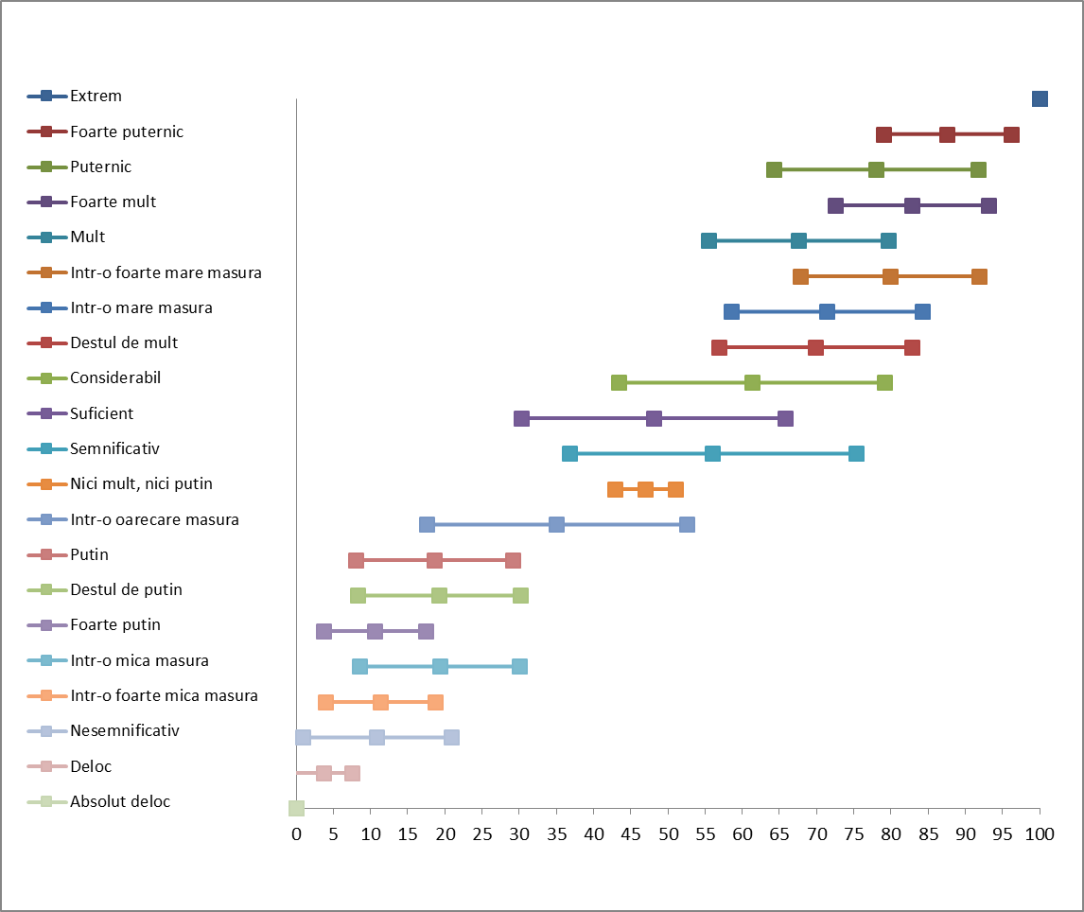
Figure 1. Intensity scores for Rumanian modifiers (mean and standard deviation)

The results from the task of choosing modifiers to identify the middle categories of a 5-point scale are shown in table 1. The numbers in the three "category columns" indicate how many percent of the respondents that preferred this particular word to identify the category, e.g. six percent of the respondents chose nesemnificativ to identify category 2 on the 5-point scale.

Table 1. Preference for category indentifier
 | CAT. 2 | CAT. 3 | CAT. 4
Absolute deloc
Deloc | 5.1
Nesemnificativ | 6.0
Intr-o foarte mica masura | 1.7
Intr-o mica masura | 14.5
Foarte putin | 8.5
Destul de putin | 12.0
Putin | 32.5 | 0.8
Intr-o oarecare masura | 11.1 | 3.4
Nici mult, nici putin | 0.9 | 51.3 | 0.8
Semnificativ | 7.7 | 11.8 | 5.1
Suficient |  | 10.9 | 2.5
Considerabil |  | 10.1 | 8.5
Destul de mult |  | 4.2 | 11.9
Intr-o mare masura |  | 2.5 | 11.9
Intr-o foarte mare masura |  | 0.0 | 3.4
Mult |  | 3.4 | 22.0
Foarte mult |  | 0.0 | 11.0
Puternic |  | 1.7 | 13.6
Foarte puternic |  |  | 9.3
Extrem

The scale values for the 5-point scale are not trivial. Some researchers define the annoyance scale with five equidistant fixed points. The corresponding scale values will be: 0 – 25 – 50 – 75 – 100. Other researchers consider a scale comprising five equally wide categories that cover the whole range as follows: 0-20, 20-40, 40-60, 60-80, and 80-100. In this case the scale values corresponding to the mid-point of each category will be: 10 – 30 – 50 – 70 – 90. This dilemma is commented on in the Fields et al. (2001) article. Fields et al. recommend the first approached with five fixed points.

Data analysis
The following values are being used in the selection of modifiers according to the ICBEN protocol, see Table 2:
Mean Intensity score. The average position on the intensity scale for a word assigned by the test persons.
Intensity score standard deviation. Calculated in the standard way. A large number indicates a lack of agreement on the intensity, i.e. the position on the intensity scale.
Difference from scale intensity. The difference between the intensity score of the word and the intensity criterion for the scale category. Thus for the word "DELOC" the value for category 2 and 3 would be: Δ#2 = 3.67-25=-21.33 and Δ#3 = 3.67-50=-46.33, etc.
Net preference score. The difference between the percentage of test persons preferring the word for a specific position and the percentage that prefer a different position. Thus the net preference for the word "PUTIN" for category 2 would be: NP#2 = 32.48 – 0.84 = 31.64, etc.

Table 2. Data for choice of modifiers
 |  | Intensity | σ | Δ#2 | Δ#3 | Δ#4 | NP #2 | NP #3 | NP #4
Absolut deloc |  | 0
Deloc |  | 3.67 | 3.82 | -21.33 | -46.33 | -71.33 | 5.13 | -5.13 | -5.13
Nesemnificativ |  | 10.87 | 9.98 | -14.13 | -39.13 | -64.13 | 5.98 | -5.98 | -5.98
Intr-o foarte mica masura |  | 11.33 | 7.42 | -13.67 | -38.67 | -63.67 | 1.71 | -1.71 | -1.71
Intr-o mica masura |  | 19.29 | 10.77 | -5.71 | -30.71 | -55.71 | 14.53 | -14.53 | -14.53
Foarte putin |  | 10.55 | 6.82 | -14.45 | -39.45 | -64.45 | 8.55 | -8.55 | -8.55
Destul de putin |  | 19.18 | 10.96 | -5.82 | -30.82 | -55.82 | 11.97 | -11.97 | -11.97
Putin |  | 18.59 | 10.53 | -6.41 | -31.41 | -56.41 | 31.64 | -31.64 | -33.32
Intr-o oarecare masura |  | 35.02 | 17.53 | 10.02 | -14.98 | -39.98 | 7.75 | -7.75 | -14.47
Nici mult, nici putin |  | 46.98 | 4.08 | 21.98 | -3.02 | -28.02 | -51.25 | 49.56 | -51.27
Semnificativ |  | 56.02 | 19.24 | 31.02 | 6.02 | -18.98 | -9.16 | -1.01 | -14.37
Suficient |  | 48.05 | 17.78 | 23.05 | -1.95 | -26.95 | -13.47 | 8.38 | -8.38
Considerabil |  | 61.27 | 17.86 | 36.27 | 11.27 | -13.73 | -18.56 | 1.61 | -1.61
Destul de mult |  | 69.85 | 13.01 | 44.85 | 19.85 | -5.15 | -16.07 | -7.66 | 7.66
Intr-o mare masura |  | 71.40 | 12.83 | 46.40 | 21.40 | -3.60 | -14.39 | -9.34 | 9.34
Intr-o foarte mare masura |  | 79.85 | 12.05 | 54.85 | 29.85 | 4.85 | -3.39 | -3.39 | 3.39
Mult |  | 67.57 | 12.12 | 42.57 | 17.57 | -7.43 | -25.40 | -18.67 | 18.67
Foarte mult |  | 82.85 | 10.31 | 57.85 | 32.85 | 7.85 | -11.02 | -11.02 | 11.02
Puternic |  | 77.93 | 13.74 | 52.93 | 27.93 | 2.93 | -15.24 | -11.88 | 11.88
Foarte puternic |  | 87.57 | 8.62 | 62.57 | 37.57 | 12.57 | -9.32 | -9.32 | 9.32
Extrem |  | 100

Selection of modifiers
The words to be used for characterization of category #2, #3 and #4 were selected by following these successive steps according to the ICBEN protocol:
- Net preference score NP ≥ 5 %
- Unsigned difference from scale intensity |Δ|≤ 15
- Net preference score within 20 points of most popular remaining candidate word
- Standard deviation within 15 points of smallest remaining modifiers' standard deviation
- Unsigned difference from scale intensity |Δ|≤ 10
- Net preference score within 15 points of most popular remaining candidate word
- Standard deviation within 10 points of smallest remaining modifiers' standard deviation
- Unsigned difference from scale intensity |Δ|≤ 5
- Net preference score within 10 points of most popular remaining candidate word
- Standard deviation within 5 points of smallest remaining modifiers' standard deviation
- Select the remaining word closest to the intensity criterion
- Select highest remaining preference score
- Select lowest remaining standard deviation score

Following this procedure the preferred modifier for category #2 will be putin (selected after step 6), for category #3 the preferred modifier will be nici mult, nici putin (selected after step 3), and for category #4 the preferred modifier will be mult (selected after step 8). In addition the modifiers for category #1 and #5 are absolut deloc and extrem respectively.

Method for constructing two standardized annoyance reaction questions
ICBEN recommends two standardized questions, one using a 5-point verbal scale and one using an 11-point numerical scale (Fields et al. 2001). The original English versions of these questions are as follows:
"Thinking about the last 12 months or so (or alternative time period), when you are here at home, how much does noise from (noise source) bother, disturb or annoy you? Extremely, very, moderately, slightly or not at all?"
"Next is a zero to ten opinion scale for how much (noise source) noise bothers, disturbs or annoys you when you are here at home. If you are not at all annoyed choose zero, if you are extremely annoyed choose ten, if you are somewhere in between choose a number between zero and ten.
Thinking about the last 12 months or so (or alternative time period) what number from zero to ten best shows how much you are bothered, disturbed or annoyed by (noise source) noise?"
These questions were translated into Romanian using an iteration of forward and backward translations in order to get a wording as close as possible to the original English text. The modifiers for the verbal scale were taken from the results referred above.
Question for the 5-point verbal scale:
Luând în considerare ultimele 12 luni, pe perioada cât aţi fost acasă, cât de mult v-a deranjat, perturbat sau creat un disconfort zgomotul produs de (sursa). Extrem, mult, nici mult nici putin, putin, absolut deloc ?
Question for the 11-point numerical scale:
La următoarea întrebare, notaţi pe o scală de la 0 la 10 cât de mult v-a deranjat, perturbat sau creat un disconfort zgomotul produs de (sursa) pe perioada cât aţi fost acasă. Dacă nu v-a creat deloc un disconfort alegeţi 0, daca v-a creat un disconfort extrem alegeţi 10, iar dacă sunteţi undeva între aceste două variante alegeţi un număr între 0 şi 10.
Gândindu-vă la ultimele 12 luni, ce număr de la 0 la 10 indică cel mai bine cât de mult v-a deranjat, perturbat sau creat un disconfort zgomotul produs de (sursa)?
References
Fields, J.M., de Jong, R.G., Brown A.L., Flindell, I.H., Gjestland, T., Job, R.F.S., Kurra, S., Lercher, P., Schumer-Kohrs, A., Vallet, M., Yano, T. (1997) "Guidelines for reporting core information from community noise reaction surveys." J. Sound. Vib. Vol. 206(5); 685-95.
Fields, J.M., de Jong, R.G., Gjestland, T., Flindell, I.H., Job, R.F.S., Kurra, S., Lercher, P., Vallet, M., Yano, T., Guski, R., Felscher-Suhr, U., and Schumer, R, (2001): "Standardized General-Purpose Noise Reaction Questions for Community Noise Surveys: Research and a Recommendation," J. Sound Vib. vol 242; 641– 679.
Günther, H., Inglesias, F., Moares de Sousa, J. (2007) "Note on the development of a Brazilian version of a noise annoyance scale", J. Sound. Vib. vol. 308, 343-347 (doi:10.1016/j.jsv.2007.06.072)
International Organization for Standardization (2003): "Acoustics – Assessment of noise annoyance by means of social and socio-acoustic surveys", ISO/TS 15666:2003 (reviewed and confirmed 2013)
Kvist, P. and Holm Pedersen, T., (2006) "Translation into Danish of the Questions and Modifiers for Socio-Acoustic Surveys", EuroNoise 2006, Tampere, Finland
Preis, A., Kaczmarek, T., Wojciechowska, H., Zera, J. Fields, J.M. (2003) "Polish version of standardized noise reaction questions for community noise surveys", Int. J. Occ. Med. And Env. Health, vol. 16(2), 155-159
Schultz, T. J. (1978). “Synthesis of social surveys on noise annoyance,” J. Acoust. Soc.
Am. 64(2) 377–405.
Yano, T and Ma, H (2004) "Standardized noise annoyance scales in Chinese, Korean and Vietnamese", J. Sound. Vib. vol 277, 583-588 (doi:10.1016/j.jsv.2004.03.020)

